**The Distributed Generation Market Demand Model (dGen): Documentation**

B. Sigrin, M. Gleason, R. Preus, I. Baring-Gould, and R. Margolis

*National Renewable Energy Laboratory*

**Technical Report**

NREL/TP-5000-xxxxx

Month Year

**Technical Report**

NREL/TP-5000-xxxxx

Month Year

**The Distributed Generation Market Demand Model (dGen): Documentation**

B. Sigrin, M. Gleason, R. Preus, I. Baring-Gould, and R. Margolis

*National Renewable Energy Laboratory*

Prepared under Task No(s). WE14.2H01, SS13.1010

**NOTICE**

This report was prepared as an account of work sponsored by an agency of the United States government. Neither the United States government nor any agency thereof, nor any of their employees, makes any warranty, express or implied, or assumes any legal liability or responsibility for the accuracy, completeness, or usefulness of any information, apparatus, product, or process disclosed, or represents that its use would not infringe privately owned rights. Reference herein to any specific commercial product, process, or service by trade name, trademark, manufacturer, or otherwise does not necessarily constitute or imply its endorsement, recommendation, or favoring by the United States government or any agency thereof. The views and opinions of authors expressed herein do not necessarily state or reflect those of the United States government or any agency thereof.

This report is available at no cost from the National Renewable Energy  
Laboratory (NREL) at www.nrel.gov/publications.

Available electronically at [SciTech Connect http:/www.osti.gov/scitech](http://www.osti.gov/scitech)

Available for a processing fee to U.S. Department of Energy  
and its contractors, in paper, from:

U.S. Department of Energy  
Office of Scientific and Technical Information

P.O. Box 62  
Oak Ridge, TN 37831-0062  
[OSTI http://www.osti.gov](http://www.osti.gov/)  
Phone: 865.576.8401  
Fax: 865.576.5728  
[Email: reports@osti.gov](mailto:reports@osti.gov)

Available for sale to the public, in paper, from:

U.S. Department of Commerce  
National Technical Information Service  
5301 Shawnee Road  
Alexandra, VA 22312  
[NTIS http://www.ntis.gov](http://www.ntis.gov/)  
Phone: 800.553.6847 or 703.605.6000  
Fax: 703.605.6900  
[Email: orders@ntis.gov](mailto:orders@ntis.gov)

*Cover Photos by Dennis Schroeder: (left to right) NREL 26173, NREL 18302, NREL 19758, NREL 29642, NREL 19795.*

NREL prints on paper that contains recycled content

Acknowledgments

This project was funded by the U.S. Department of Energy Solar Energy Technologies and Wind and Water Technologies Programs. We thank X,Y, Z, Easan Drury, Tony Jimenez, Jarett Zuboy for input and assistance on this project. Opinions represented in this article are the authors’ own and do not reflect the view of the U.S. Department of Energy or the U.S. Government. This work was supported by the U.S. Department of Energy under contract number DE-AC36-08GO28308

List of Acronyms

CBECS Commercial Building Energy Consumption Survey

CSI California Solar Initiative

CSP Concentrating solar power

DER Distributed energy resource

dGen Distributed Generation Market Demand model

DHS U.S. Department of Homeland Security

DOE U.S. Department of Energy

DSIRE Database of State Incentives for Renewables &

Efficiency

DSM Digital surface model

EIA U.S. Energy Information Administration

GIS Geographic information system

HSIP Homeland Security Infrastructure Program

LCOE Levelized cost of energy

LiDAR Light detection and ranging

NREL National Renewable Energy Laboratory

NSRDB National Solar Radiation Database

PV Photovoltaic(s)

R&D Research and development

RECS Residential Energy Consumption Survey

ReEDS Regional Energy Deployment System model

SAM System Advisor Model

SolarDS Solar Deployment Systems model

TMY Typical meteorological year

TOU Time of use

TPO Third-party ownership

URDB Utility Rate Database

VRRE Variable renewable resource energy

Executive Summary

The Distributed Generation Market Demand model (dGen) is a geospatially rich, bottom-up, market-penetration model that simulates the potential adoption of distributed energy resources (DERs) for residential, commercial, and industrial entities in the continental United States through 2050. The National Renewable Energy Laboratory (NREL) developed dGen to analyze the key factors that will affect future market demand for distributed solar, wind, storage, and other DER technologies in the United States. The new model builds off, extends, and replaces NREL’s SolarDS model (Denholm et al. 2009a), which simulates the market penetration of distributed PV only. Unlike the SolarDS model, dGen can model various DER technologies under one platform—it currently can simulate the adoption of distributed solar (the dSolar module) and distributed wind (the dWind module) and link with the ReEDS capacity expansion model (Appendix C). The underlying algorithms and datasets in dGen, which improve the representation of customer decision making as well as the spatial resolution of analyses (Figure ES-1), also are improvements over SolarDS.

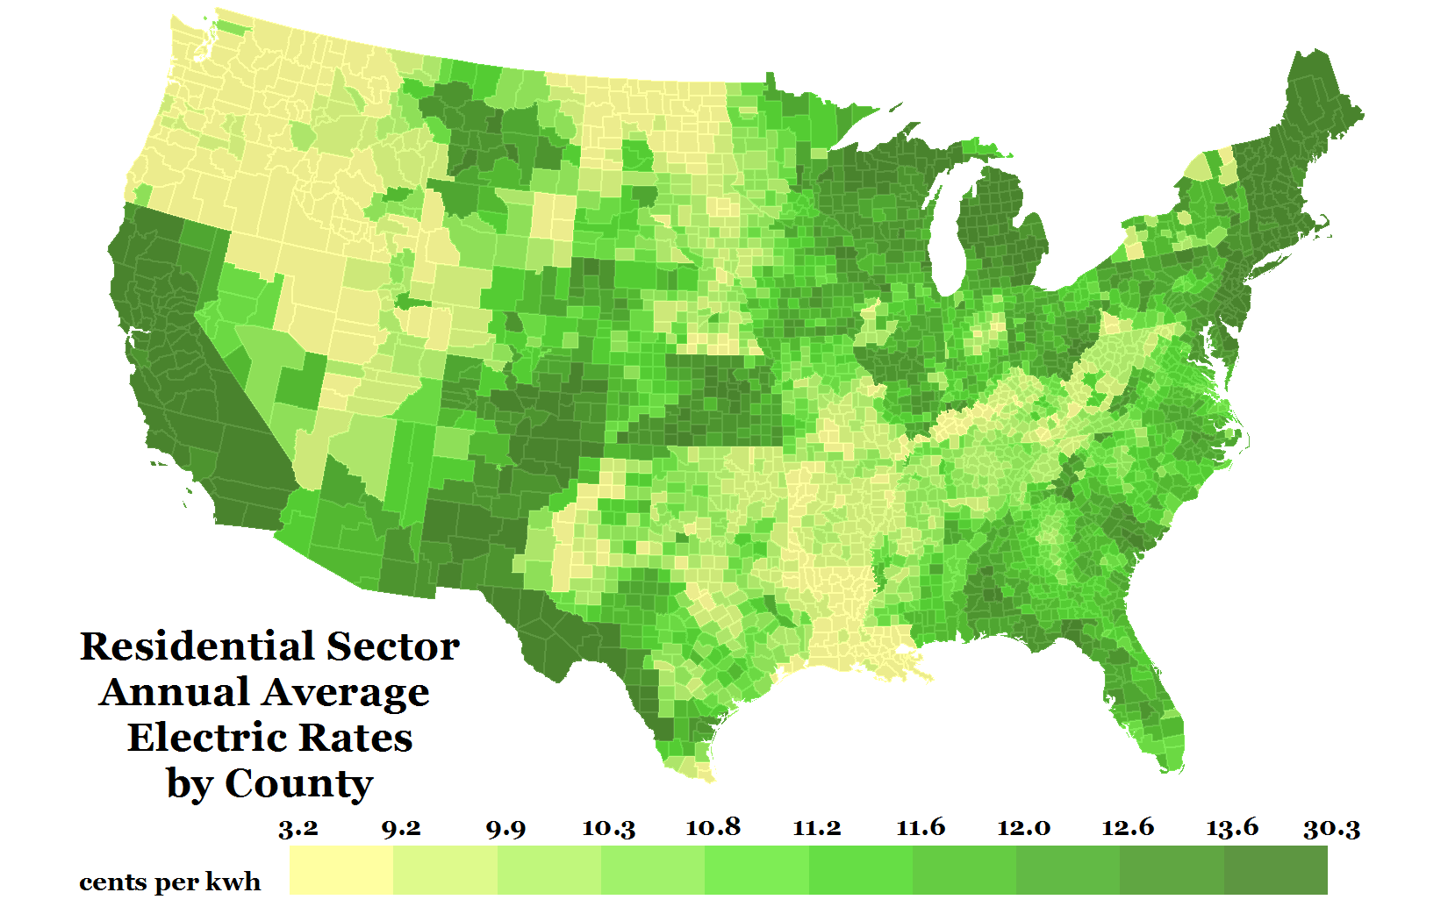

Figure ES-1. DER Adoption is modeled using a an agent-based approach for each of the 3,108 counties in the continental U.S. in the residential, commercial, and industrial sectors

Market diffusion of DER technologies is simulated in 2-year intervals from 2014 through 2050 based on various market factors for the residential, commercial, and industrial sectors within each U.S. county. The consumer demand is modeled through an agent-based approach that includes four overarching steps:

1. Generating agents (i.e., potential customers) and their assigning them attributes based on a probabilistic representation of individual customer types.
2. Applying technical and siting restrictions including resource quality, building availability, and load constraints to develop measures of technical potential for each of those agents.
3. Performing economic calculations using cash flow analysis incorporating project costs, prevailing retail rates, incentives, and net metering considerations.
4. Calculate market share of each technology by simulating technology adoption based on Bass-style adoption and other considerations of consumer behavior.
5. Generate automated visualization and output reports including annual and cumulative capacity deployed, number of systems installed, system generation, and multiple other measures of technical and economic performance.

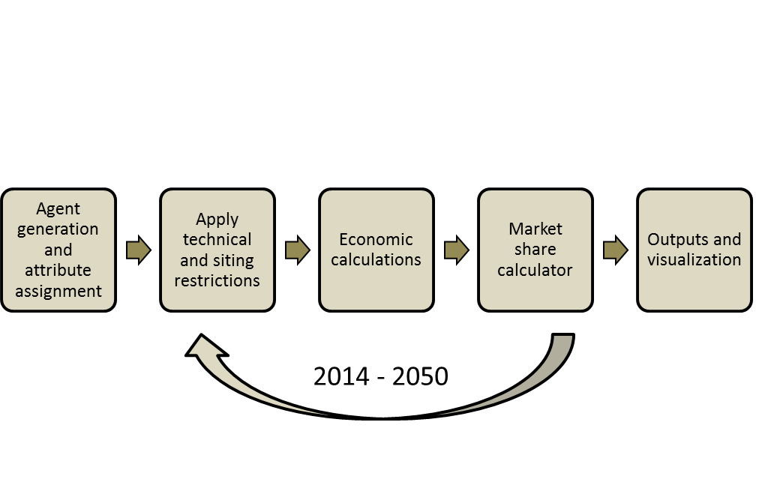

Figure ES-2. dGen model structure

Users of dGen can simulate a single technology or multiple technologies with agents considering all technology options simultaneously. Results are presented at the state and national level for a number of key metrics, including adoption penetration, cumulative and annual installed capacity, generation, market value, and levelized cost of energy.

Model users can customize numerous parameters related to current and future DER performance improvements and cost reductions, customer financing structures, market projections (e.g., load and rate growth), siting criteria, and incentive and net metering policies. These inputs provide the ability to investigate the effects of a diverse set of scenarios on market potential and to identify the critical market factors that drive end-use demand. As a result, dGen is a powerful tool for exploring pathways through which the U.S. DER market could develop and identifying factors that could help meet deployment goals.

This report documents the model structure and underlying datasets, noting differences from the original SolarDS model. Note that it does not present results using the model, which will be released in separate follow on documents. Our primary intent here is to document our methods in a way that will enable other modelers/analysts to build off of our approach. Finally, public distribution of the model is currently not available due to its deep integration with a number of spatially-resolved datasets (referred here as the ‘data backbone’) as well as limitations on sharing proprietary datasets.

Table of Contents

Executive Summary v

List of Figures ix

1 Introduction 1

2 Potential Customer (Agent) Identification 1

2.1 Methodology for Categorizing Agents 2

2.1.1 Assigning Attributes to Agent Locations 2

2.1.2 Sampling from Potential Locations 4

2.1.3 Sampling Agent Annual Electric Load 4

2.2 Advantages and Limitations of dGen Agent-Based Approach 5

2.2.1 Generating Statistically Probable Representations of Agent Types 5

2.2.2 Decreasing Model Bias and Quantifying Model Uncertainty 6

2.2.3 Flexibility in Model Applications 6

2.2.4 Flexibility for Model Enhancement 6

3 Establishing Technical Potential 7

3.1 Distributed Energy Resource Assessment 7

3.2 System Performance 7

3.3 Siting Criteria and Land-Use Mapping 8

3.4 Selecting Optimal System Configurations 9

4 Economic Calculations 10

4.1 System Costs 10

4.2 Financial Incentives 11

4.3 Financing Assumptions 11

4.3.1 Host-Ownership Business Model 11

4.3.2 Third-Party Ownership Business Model 12

4.4 Electricity Rates and Rate Structures 12

4.4.1 URDB Rate Tariffs 12

4.4.2 Annual Average Flat Rates 15

4.4.3 User-Defined Flat Rates 16

4.5 Excess Generation Value (Net Metering) 16

4.6 Bill Savings Calculator 17

4.7 Value of Avoided Carbon Emissions 17

4.8 Cash Flow Analysis 18

5 Modeling Market Diffusion 18

5.1 Business Model Selection 20

5.2 Market Diffusion 20

6 Reporting and Analysis 22

7 Future Work 22

References 23

Appendix A. Rooftop Photovoltaic Information 27

A1. Solar Resource 27

A2. Rooftop Technical Potential 28

A2.1 Background 28

A2.2 Technical Potential Caps 29

A2.3 Regional Variation in Rooftop Configuration 29

Appendix B. Distributed Wind Information 37

B1. Wind Resource 37

B2. Turbine Performance 38

B3. Turbine Height and Size Restrictions 41

B4. Distributed Wind Costs 44

Procedure Summary for Current Installed Costs 44

Turbine Costs 45

Height as a Function of Rated Power 45

Marginal Tower Height Costs 46

Final Cost Data for Model Input 47

Future Capital Costs 48

Operation and Maintenance Costs 49

Appendix C. Linkage with ReEDS Capacity Expansion Model 52

List of Figures

Figure ES-1. DER Adoption is modeled using a an agent-based approach for each of the 3,108 counties in the continental U.S. in the residential, commercial, and industrial sectors v

Figure ES-2. dGen model structure vi

Figure 1. Comparison of dGen residential customer locations to land legally zoned for residential use in Boulder, Colorado (Source: NREL) 9

Figure 2. Illustrative summary of optimal wind turbine sizes and hub heights for each market segment (Source: NREL) 10

Figure 3. Geographic coverage of all rates in the URDB (Source: OpenEI 2014) 13

Figure 4. Geographic coverage of rates from URDB used in dGen (Source: OpenEI 2014) 14

16

Figure 5. Annual average electricity rates for residential customers by county (Source: EIA 2015a) 16

Figure 6. Annual and cumulative adoption rates simulated using the Diffusion of Innovation framework (Source: Bass 1969) 19

Figure 7. Maximum market share as a function of payback period based on different sources (Source: R.W. Beck 2009; EIA 2004; Paidipati et al. 2008; Sigrin and Drury 2014) 20

Figure 8. Map of PV resource derived from NSRDB 10 km Gridded Hourly Solar Radiation Database 27

Figure 9. Distance to the nearest residential, commercial, and industrial presence cells, respectively; each building received a score of 1 for either residential or 1 for non-residential (commercial/industrial) based on whichever building use had the smaller distance 31

Figure 10. Daytime and nighttime population in Boulder, CO; buildings were given a score of 1 for residential where the nighttime population was greater than the daytime population and a score of 1 for non-residential where the daytime population was greater than the nighttime population 31

Figure 11. Building footprint size can be used as a predictor of building use, as smaller buildings tend to be residential (green area), and larger buildings tend to be non-residential (blue area); an area of Boulder, CO is shown as an example 32

Figure 12. Map illustrating the accuracy of classifying residential and non-residential buildings in San Francisco, CA 33

37

Figure 13. Annual average gross capacity factor for a modeled International Electrotechnical Commission Class II turbine at an 80-m hub height and 200-m horizontal resolution (AWST 2012a) 37

Figure 14. Normalized wind turbine power curves used to calculate power production based on size and technology evolution 41

Figure 15. Graphical workflow illustrating the analysis used to develop and combine each of the factors that affects the range of developed turbine hub heights at each customer location. 42

Figure 16. Procedure for determining installed cost values used for wind in dGen 45

Figure 17. Wind turbine operation and maintenance cost assumptions by size used in dGen 50

Figure 18. ReEDS map showing the ReEDS regional structure; ReEDS includes 134 model balancing areas (shaded areas) and 356 wind and CSP resource regions (light gray lines) 52

Figure 19. Schematic of the ReEDS-dGen linkage; dGen passes rooftop PV capacity, capacity factors, and retail electricity prices to ReEDS before each ReEDS solve, and ReEDS returns the rooftop PV marginal curtailment rate for the next dGen year 53

List of Tables

Table 1. Summary of Key Data Sets used in Characterizing Agents through Data Backbone 3

Table 2. Default Financing Assumptions for Host-Owned Systems by Sector 11

Table 3. Financing Assumptions for Third-Party-Owned Systems by Sector 12

Table 4. User Input Table for Defining the Relative Prevalence of Different Rate Structures, by Sector 15

Table 5. Summary of Building Use Classification Model 33

Table 6. Baseline 2015 Distributed Wind Turbine Performance 39

Table 7. Future performance characteristics for the different turbines used in dGen 40

Table 8. User input table defining minimum parcel size required for each turbine hub height, populated with current default values 43

Table 9. User input table defining the maximum allowable percent of heavily developed land at each agent location for each turbine hub height, populated with current default values 43

Table 10. User input table defining the canopy clearance required for each turbine size (i.e., rated capacity), populated with current default values 44

Table 11. Histogram of Turbine Height and Rated Power 46

Table 12. Marginal Tower Cost 47

Table 13. Comparison of Actual Tower Height Ranges to the Ranges used in the Model 47

Table 14. Final Adjusted Turbine Costs 48

Table 15. Operation and Maintenance Cost Assumptions 50

1. Introduction

The Distributed Generation Market Demand model (dGen) was developed by the National Renewable Energy Laboratory (NREL) as a tool to analyze the key factors that will affect future market demand for distributed energy resource (DER) technologies in the United States. The model currently is capable of simulating the adoption of distributed solar (via its dSolar module) and wind (via its dWind module) technologies and has explicitly been designed to facilitate incorporation of additional technologies. It can analyze the impact of several market drivers on DER market potential, including research and development (R&D) driven price and performance improvements, financial rebates, net energy metering or other methods of valuing DER energy exports to the grid, retail electricity rates and rate structures, and other factors.

Behind-the-meter DER demand is simulated by dGen at 2-year increments from 2014 through 2050 for residential, commercial, and industrial customers. It builds off, extends, and replaces NREL’s Solar Deployment Systems (SolarDS) model (Denholm et al. 2009a; Drury et al. 2013). SolarDS was developed to explore rooftop photovoltaic (PV) market demand and has been used to inform solar market evolution for the *SunShot Vision Study* (DOE 2012) and ongoing follow-up studies, the *Renewable Electricity Futures* study (Hand et. al. 2012), and the recent *Wind Vision Study* (DOE 2015). Though many of same parameterizations and assumptions used in SolarDS are also used in dGen, the updated model accesses updated databases of current electricity rates and rate structures, projections of future electricity rates, net-metering characteristics, and incentives—to name a few.

The success of SolarDS stimulated development of a common modeling platform that could simulate the market demand of multiple DER technologies, with a consistent set of parameters and algorithms used to simulate customer adoption but with appropriate distinctions for individual technologies. Under the current platform, the user may simulate the diffusion of distributed solar or distributed wind individually or in parallel, with the simulated agent (i.e., potential customer) considering both technology options simultaneously. Similar to SolarDS, dGen is fundamentally geospatial, capturing regional variation in the underlying factors that affect market demand across the United States; however, the model captures spatial relationships at a significantly higher level of detail than SolarDS using a ‘data backbone’ of geographically –resolved overlaid data layers.

The increased spatial resolution of dGen not only permits more robust deployment forecasts, but also adds new spatial capabilities. Example capabilities include correlating DER adoption with socio-demographic data and electric vehicle purchases, or to overlay deployment forecasts with distribution networks to improve our understanding local impacts of high levels of DER adoption. Nearly all data in the model is mapped spatially--site-specific parameters are then linked with locally and regionally variable datasets of other market factors through the data backbone such as electricity rates and rate structures, policy incentives, and electricity demand. These datasets are combined within a geographic information system to model market penetration at the county and parish levels, and results are aggregated to the state and national levels.

The remainder of this report describes the methods, data, and assumptions behind each major aspect of dGen: agent identification (Section 2), technical potential (Section 3), economic calculations (Section 4), market diffusion (Section 5), and reporting and analysis (Section 6). Finally, Section 7 briefly discusses future work. A set of appendices provides additional information on PV and wind applications of dGen as well as the linking of dGen and NREL’s Regional Energy Deployment System (ReEDS) model.

1. Potential Customer (Agent) Identification

Forecasting the deployment of DERs and utility-scale resources requires different approaches than forecasting the capacity expansion of utility-scale resources (PNNL 2012; Short et al. 2011), because DER investment decisions are made by individuals and not profit-maximizing firms. Other important differences are that DER value is typically determined by offsetting energy consumption at the retail (not wholesale) level, DER technologies are relatively unproven and thus have considerable scope for cost/performance improvement, and nonfinancial technology characteristics (e.g., novelty, appearance, and conferred status) can influence the DER adoption decision. As such, dGen simulates the market adoption of DERs through an aggregation of individual adoption decisions made by potential residential and nonresidential customers or “agents.”

To capture the variation in attributes driving DER adoption, dGen uses a statistical framework for representing the individual-level characteristics through a set of agents for every county in the United States. Each agent is assigned a set of attributes representing a likely configuration—such as, location, system capacity, and annual electricity consumption—by sampling from distribution of the same parameters. Additionally, agents are assigned a weighting factor corresponding to the number of similar customers they represent within the county. This framework reflects two key principles: 1) investment decisions are made at the individual level based on the agent’s attributes, and 2) using a sampling-based approach accurately represents the variability in the population and thus improves the determination of attributes that predict adoption.

* 1. Methodology for Categorizing Agents

The methodology for categorizing potential agents includes three main steps: 1) assigning attributes to possible system-installation locations, 2) sampling from possible system locations, and 3) sampling end-user annual electrical demand in kilowatt-hours (kWh). This process reflects NREL’s core design principle that location and end-user demand are the most important attributes for determining an agent’s propensity for adoption. At a high-level, the model uses 200m resolution to represent locations of individual agents, which are then aggregated to the county level

* + 1. Assigning Attributes to Agent Locations

The first step in characterizing agent types is to assign attributes to all potential agent locations based on land-use grids (spatial layers). Each land-use grid represents the set of potential location(s) of agents within a given market segment at the resolution of a 200-m by 200-m cell for the entire United States; the location of each cell is used as a primary key to associate additional spatially dependent attributes (Table 1).

Table 1. Summary of Key Data Sets used in Characterizing Agents through Data Backbone

|  |  |  |
| --- | --- | --- |
| **Data Set** | **Source** | **Spatial Resolution** |
| Resource Quality - Annual Energy Production | AWS (2012a), AWS (2012b), Dobos (2015), George et al. (2007), NSRDB (2015) | 200 m by 200 m |
| Potential Agent Locations (Land-Use Mask) | ORNL (2011), HSIP (2012) | 200 m by 200 m |
| Additional Technology-Dependent Siting Criteria (e.g., roof orientation and maximum turbine height) | ORNL (2011), HSIP (2012), Gagnon (2015) | 200 m by 200 m |
| Prevailing Retail Electricity Rates (2014) | OpenEI (2014) | Electric Service Territories |
| Applicable Incentive Policies | DSIRE (2014) | Variable: Electric Service Territories,  Counties, State, Nation |
| Existing Net-Metering Availability | Barnes et al. (2015) | State |
| Total Annual Electric Load by County |  | County |
| Total Count of Electric Customers by County | Ventyx (2012) | County |
| Microdata Representations of Customer-Level Electric Load | EIA (2008) | Census divisions (multistate regions) |
| Load Growth Projections | EIA (2015b) | Census divisions (multistate regions) |
| Electricity Rate Projections | EIA (2015b) | Nation |
| Financing Parameters | DOE (2012) | Nation |
| Capital Cost Projections | DOE (2012) | Nation |
| R&D-Based Performance Improvements | DOE (2012) | Nation |

By assigning each agent an actual location, each potential agent can be associated with a number of attributes from datasets in the data backbone using a simple spatial overlay (i.e., intersection). In the agent generation step, each customer location is attributed with annual and hourly energy production for a set of possible system configurations,[1] technology-specific siting parameters governing technical feasibility (e.g., roof slope or maximum turbine height), prevailing financial incentives, electricity rates and rate structures, and existing net-metering policies or policies for valuing excess system production exported to the grid. Several other key customer attributes—such as capital costs, financing options, and other market projections—are resolved only at the state, regional, or national level. This process of spatial overlay results in a nearly complete characterization of the attributes at each 200-m by 200-m potential customer location.

* + 1. Sampling from Potential Locations

Because the land-use grids represent potential agent locations rather than known customer locations, they are interpreted in the model as the statistical pool of possible configurations of customer attributes that exist within the county, not the discrete population of every potential customer in the county. Additionally, there are likely to be relatively small differences between each 200m cell[2], which permits aggregating cells to unique combinations of location-based attributes, which significantly reduces the number of distinct types of customer locations within each county. Based on this interpretation, dGen uses weighted random sampling to draw customer-type configurations from the population of feasible and unique customer locations/attribute combinations.

* + 1. Sampling Agent Annual Electric Load

Energy consumption is a critical agent attribute, because the primary financial motivation of DER adoption is to reduce energy costs through system generation. However, we know of know of no nationally resolved data sets of individual-level energy-consumption patterns. Instead, dGen uses the U.S. Energy Information Administration’s (EIA’s) Residential Energy Consumption Survey and Commercial Building Energy Consumption Survey (EIA 2008; EIA 2015b) to assemble distributions of customer-level energy consumption across the country and assign an agent’s level of energy consumption.

Both surveys collect information on the energy consumption patterns of residential and commercial end users.[3] The results are anonymized and compiled into regional microdata samples that represent the individual survey responses, including annual electric consumption at the individual household and commercial building levels. Each individual survey response also includes a survey or sample weight, which is used to reconstruct the prevalence of that type of end user in the general population. As with the location types described earlier, these microdata define the statistical pool’s possible electrical or thermal energy consumption. Unlike the location types, the electric demand microdata are only resolved spatially to the coarse scale of large, multistate regions. As a result, it is infeasible to determine the exact customer-level electric demand at each 200-m by 200-m customer location.

Because the exact customer-level electric demand cannot be determined for each location, dGen uses a statistical sampling approach, randomly drawing customer-level electric demand from the pool represented in the EIA microdata. This process is performed using a weighted random sampling with replacement, in which the weighting is based on the prevalence of each customer, as determined by EIA. The model then assigns each sampled electric-load value and its corresponding weight to one of the initial customer types.

As a result of the sampling methodology, the aggregate sum of the customer-level electric-load values sampled to customer types can differ from the total county-level electricity load for a given market segment (Ventyx 2012). To ensure that county-level load constraints are binding, the sampled electric-load values are treated as intensity measures rather than absolute values. The county-level load is then allocated across the customer types, with the amount of load in each customer type proportional to the sampled load value from the microdata. Concurrently, a similar scaling process is applied to apportion the county-level customers to individual customer bins, in proportion to the EIA microdata weights. The resulting load and customer values preserve the county-level totals across the discrete set of customer types as well as the general variability in intensity of electric demand found in the region.

By combining these values with the location-based characteristics assigned in steps 1 and 2, the customer types for each county are fully parameterized and ready for incorporation into the process of agent-level economic analysis and diffusion modeling.

* 1. Advantages and Limitations of dGen Agent-Based Approach

The process of agent categorization detailed above is a relatively novel technique for modeling the market penetration of DERs. As such, we describe some of the advantages and limitations of this technique below.

* + 1. Generating Statistically Probable Representations of Agent Types

Modeling national adoption decisions involves two contradictory impulses: the preference to model individual decision making and the infeasibility of parameterizing individual preferences and attributes because of data limitations. Therefore, it is critical to represent population variance fully, because central tendencies of a population do not represent the prototypical diffusion process in which initial adopters of a technology are themselves outliers(Rogers 2003)*.* Two concrete examples of this disconnect include the fact that early adopters of rooftop PV have substantially higher incomes than their non-adopting peers (Rai and Sigrin 2013; Drury et al. 2012, and the DER marginal value in California, which is the largest market in the United States, increases with the end user’s electrical consumption because higher consumption is offset at a higher tier rates. That is, using median values of income or electrical demand would inadequately represent the propensity for adoption—at least in the initial stages of diffusion.

Thus, the sampling process used in dGen overcomes limitations of the best available data sets by generating likely representations of customer types. By using random sampling to extract and link agent-level attributes that are based on the statistical prevalence of those attributes, the resulting customer types will tend to represent the most common configurations of agents within each county. The component of randomness also enables the model to incorporate rare customer types as appropriately small components of the overall market. As a result, the customer types generated produce statistically faithful representations of the variation in types of customers likely to be present within each county and market segment.

* + 1. Decreasing Model Bias and Quantifying Model Uncertainty

A second significant advantage of the techniques used to characterize agent types is that it facilitates quantifying uncertainty both in the input data and model results. Realistically, data limitations ensure that there will always be some uncertainty about the true attributes of the underlying population. Therefore, a deterministic approach will almost certainly be biased and, more importantly, biased in the same way for every model run. Furthermore, the degree of bias cannot be quantified, so uncertainties caused by data limitations are not transparent in model outputs.

The statistical sampling framework used by dGen acknowledges this source of model bias by treating uncertainty related to agents’ actions and attributes in a more sophisticated and appropriate manner. By using random sampling, the model can generate a large number of unique, equally probable deployment pathways, reflecting the uncertainties in data and agent decision making. Users of the model can produce a different sample of customer types for each model run and leverage this ability to perform Monte Carlo simulations of DER market penetration where variance in model outcomes can be used to quantify the uncertainty in the model and its assumptions. For example, a user could test a given scenario using 100 different customer-type realizations. The median output values from the 100 simulations would represent the most probable single prediction of the scenario outcome, based on the input data, whereas the 5th and 95th percentile values would place a 90% confidence interval around the median prediction.

* + 1. Flexibility in Model Applications

A third significant benefit of the framework is derived from the fact that users can specify the number of unique agents to model in each market segment and county. Increasing the number of agents increases the required run time while reducing the variance between results. The user can change the number of customer types to tune the model for different analysis requirements.

By increasing the number of agents generated, the user can decrease the variance in model results, because each region is represented by a larger and, therefore, more representative sample of the set of all potential customer configurations. At the extreme level, the number of customer types could be set to the total number of customers within each county, such that the theoretical combination of all customer attributes are fully represented in the model; however, as more customer bins are modeled in each county, the overall run time of the model increases. This feature of the model can be leveraged to use the model for different applications. For example, it could be used to perform a tiered scenario modeling process. A user could initially set the number of customer types relatively low to perform quick comparisons of the nationwide effects of different policy, R&D, or cost-improvement scenarios. Then, based on these preliminary results, the user could model specific scenarios of interest in depth at a more granular spatial resolution (e.g., at the state level) by raising the number of customer bins.

* + 1. Flexibility for Model Enhancement

One final advantage of the method used for characterizing customer types in dGen is that it provides a flexible foundation for integrating additional customer attributes, particularly when the covariance structure can be established with the existing attributes. For example, survey data relating demographic or behavioral attributes to a customer’s propensity for adoption could be incorporated using the probabilistic sampling framework. With this approach, the model can continue to be enhanced to account for not only additional predictive customer attributes, but also for important relationships and combinations of those attributes.

1. Establishing Technical Potential

After agents have been categorized, dGen establishes measures of the technical potential of each technology type by excluding system installation sites that are technically infeasible and configurations that are either infeasible or wholly inferior to alternative configurations. Specifically, this process involves an assessment of resource quality: translating resource assessments to estimates of system production including R&D-related performance improvements and restrictions on siting. The output of this assessment is a set of technically feasible system configurations for each agent based on their sampled location, should any such feasible configurations exist. Each of the technically feasible configurations is then evaluated in the economics module, which retains only the most profitable configuration for each agent.

* 1. Distributed Energy Resource Assessment

The availability and quality of renewable energy resources, particularly wind and sunlight, vary dramatically within the United States, with important implications for DER electricity generation and value. This section explains the data and algorithms common to all modeled technologies used to represent resource quality and energy production. Technology-specific processes are described in the Appendices.

Resource assessments have been conducted for each technology. For distributed PV, the resource is based on a 10-km by 10-km gridded data set of hourly solar irradiance (NSRDB 2015) (Appendix A), which is down-scaled into 200-m by 200-m cells to be consistent with other operations. The PVWatts® tool (Dobos 2015) is used to automatically evaluate system generation for each agent based on rooftop characteristics for that agent (irradiance, panel tilt, and panel orientation) producing an hourly profile of energy generation for a typical meteorological year (TMY).

A similar process is used for wind based on a 20-km by 20-km gridded data set of hourly wind-speed data down-scaled into 200-m by 200-m grid cells using a complementary data set published by AWS TruePower (AWST 2012a; AWST 2012b). However, instead of using PVWatts, dGen uses a novel method of evaluating energy production for a fixed set of current and future model distributed-scale turbines (Appendix B).

* 1. System Performance

Like most market models, dGen uses current and estimated future technology performance, which, when combined with the geo-specific resource information, estimates energy production for each agent location over time. The model also provides a method that clarifies how potential investments in technology performance can impact deployment. Current and future performance model inputs are described in Appendix A (PV) and Appendix B (wind). The model does not support the identification of technology improvement opportunities or show how improvements change performance or cost. However, it can describe the potential market impact of achieving different performance levels.

* 1. Siting Criteria and Land-Use Mapping

Not every 200-m grid cell modeled in dGen is suitable for DER systems. To be suitable, a site must meet general and technology-specific criteria. For all technologies, a site must be located in the appropriate zoning type (e.g., residential, commercial, or industrial), and, for residential systems, the building must be owner occupied.[4] Technology-specific criteria include, for example, wind systems restricted based on factors such as high population density and tree cover and solar requirements of a minimum roof size and configuration. See the Appendices for additional information on the technology-specific criteria and methodology.

Land available for DER installation must be on commercial, industrial, or residential property. The model uses a national series of high-resolution land-use grids (spatial layers) for each market segment to identify whether customers from a given market segment are likely to be present in each 200-m by 200-m area. Figure 1 is an example of the residential land-use mask for Boulder, Colorado, showing the close correspondence with land zoned residential by the city. The land-use grids do not characterize land use perfectly, but they capture the general extent of land used by each customer segment, especially at the aggregate (county, state, nation) level.

Customer locations for the residential sector were developed primarily using an analysis of the LandScan™ USA geospatial grids, which provide a fine-resolution estimate of daytime and nighttime population (ORNL 2011). These population grids were overlaid and combined to determine the ratio of nighttime to daytime population. Under the assumption that residential areas tend to be more heavily populated at night (when most people are home) than during the day (when many people are at work or school), grid cells with a nighttime-to-daytime ratio above one were classified as residential. A second analysis removed grid cells coinciding with known locations of non-residential facilities with high nighttime populations, including prisons, hotels, motels, college campuses, and industrial complexes (HSIP 2012). For the commercial and industrial sectors, the customer location grids were derived using a dataset of known business locations. These locations were separated into commercial and industrial groups based on two-digit codes from the North American Industry Classification System (NAICS), each point location was expanded by a 90-m radius, and the resulting areas were overlaid on the grid to identify cells occupied by facilities of each sector.

All three grids are resolved to the same spatial resolution (200 m by 200 m) as the renewable energy resource data, allowing for the seamless integration of the two data sets. Within dGen, these land-use masks are treated as the entire pool of candidate customer locations for each market segment, and thus they constrain DER diffusion. This approach helps avoid over-prediction of the market by identifying locations where siting criteria would restrict adoption despite sufficient resource quality and customer demand, and it can identify the areas suitable for different types of DER technologies.

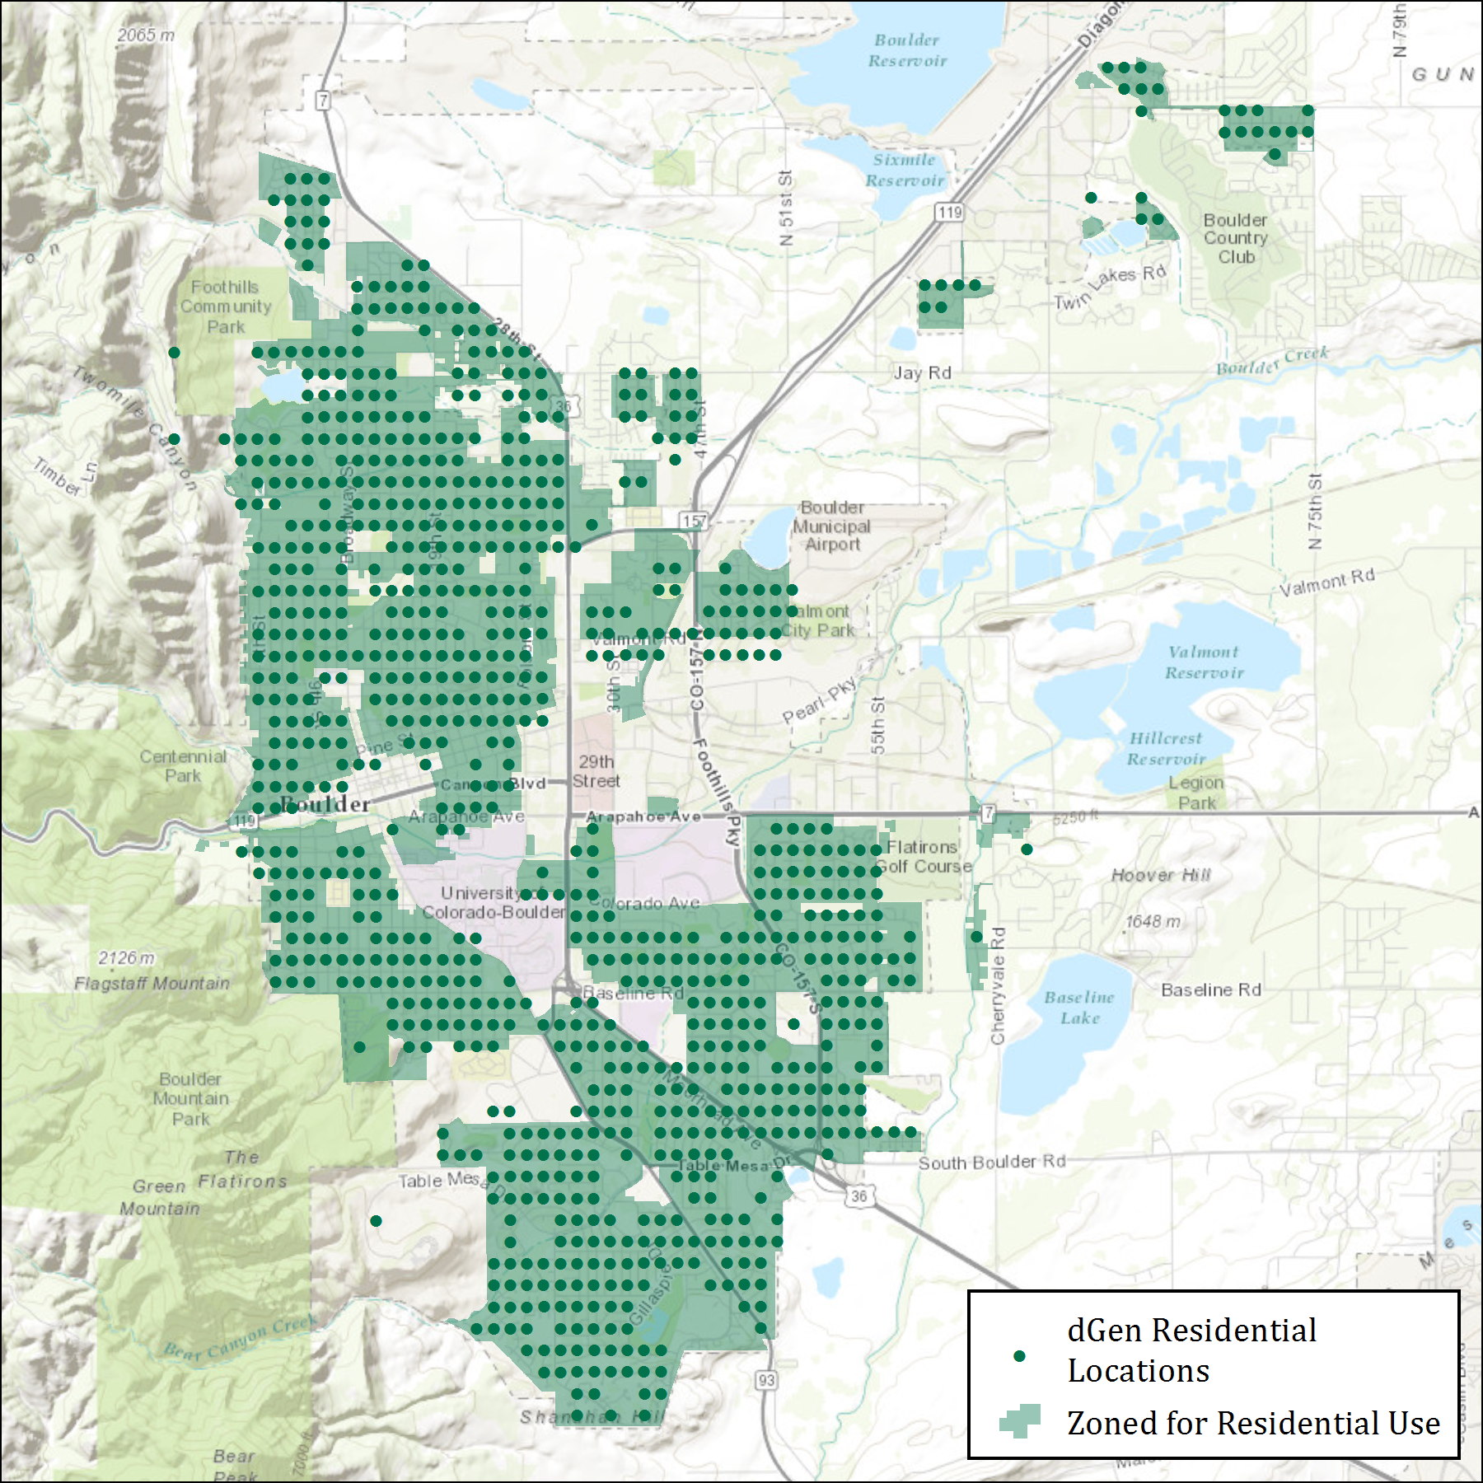

Figure 1. Comparison of dGen residential customer locations to land legally zoned for residential use in Boulder, Colorado (Source: NREL)

* 1. Selecting Optimal System Configurations

Even after applying generic and technology-specific restrictions on system configuration, there are likely to be multiple feasible configurations for an agent. Therefore, dGen selects the system configuration with the lowest levelized cost of energy (LCOE) while ensuring that annual system generation meets 25% –115% of the customer’s annual electricity consumption, aiming for a 95% offset in areas with net metering and 50% in areas without net metering (Davidson and Margolis 2015), but the user can adjust them. This algorithm produces reasonable estimates of optimum system configurations for each agent. Figure 2 illustrates this selection process for wind turbines, showing the system configuration preference for the three sectors, where the area of each circle is proportional to the amount of capacity that would be installed at the selected height-capacity combination.

After this rapid screening, a more thorough cash flow analysis is conducted to determine the financial viability of the selected system configuration.

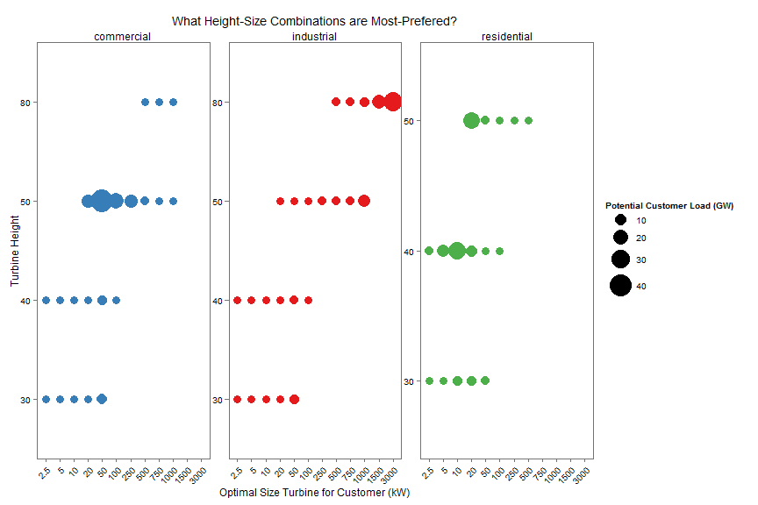

Figure 2. Illustrative summary of optimal wind turbine sizes and hub heights for each market segment (Source: NREL)

1. Economic Calculations

The economics of each DER technology are determined using discounted cash flow analysis to determine the profitability (e.g., the payback period, net present value, and monthly electricity bill savings) over the system’s lifetime. This approach assumes that the DER value is created by reducing the electricity or fuel bills that the agent would have paid had they not adopted. Specifically, expenses include initial capital costs, such as the down payment and monthly loan/lease payments, and annual operation and maintenance requirements. Revenue includes energy bill savings, applicable financial incentives, and tax-based credits, such as depreciation and interest rate deductions for nonresidential customers.

* 1. System Costs

Three components of system cost are incorporated in dGen: installation capital costs and variable ($/kWh) and fixed ($/kW/year) operation and maintenance costs. Each cost component includes cost-reduction trajectories based on exogenous reductions or cost reduction through learning curves. Assumptions for current and potential future costs are described in the Appendices. Capital costs are defined for each sector (residential, commercial, and industrial) and can vary by project size to reflect economies of scale.

* 1. Financial Incentives

The model provides a flexible framework for modeling the full life cycle impact of a range of potential state and federal incentives. Users can model current (2015) incentives, based on the Database of State Incentives for Renewables & Efficiency (DSIRE) database (DSIRE 2014). These incentives are applied across a range of geographic scales—such as electric service territories, counties, states, and nationwide—and are categorized as either production based ($/kWh), a tax credit as a percentage of installed costs, or a fixed-value rebate. The DSIRE database specifies the expiration date of incentives and the maximum amount that will be dispersed to a project. An expiration of 2020is assumed in dGen for incentives with no announced expiration date. As of this writing, the federal Investment Tax Credit, a key incentive for spurring early adoption, is scheduled to expire in 2016 for residential systems and to decrease from 30% of installed cost to 10% for non-residential systems, which is the assumption used in dGen.

Alternatively, users may manually prescribe a variety of incentive structures—tax, production, and rebate—with various levels, caps, and expiration dates. These manual incentives can be assigned to specific states or nationally and used to either overwrite the DSIRE incentives or phase in for any future model year. Several built-in default scenarios for future incentives—including low, medium, and high scenarios for each incentive structure—can also be defined. Using this flexible framework, dGen permits in-depth analysis of the effects of policy incentives on DER deployment.

* 1. Financing Assumptions

The economic value of a DER system is affected by the financing structure used by a potential customer. In dGen, DER systems may be adopted through a host-ownership business model, whereby the customer directly owns the system, or a third-party model, whereby the customer leases the system, receiving all system energy generation in exchange for a fixed monthly payment. In both models, the DER systems provide no additional costs or benefits beyond their stated lifetime. Users are able to edit all of the default financing assumptions to investigate the effects of financing structures on market outcomes.

* + 1. Host-Ownership Business Model

Under host ownership, the agent owns and operates the DER system independently, accruing all costs, revenues, and financial incentives. The agent is assumed to use financing to acquire the system, unless a down payment of 100% is selected. Table 2 lists the default financial assumptions for host ownership.

Table 2. Default Financing Assumptions for Host-Owned Systems by Sector

|  |  |  |  |
| --- | --- | --- | --- |
| Market Segment | Residential | Commercial | Industrial |
| Loan Rate | 6% | 6% | 6% |
| Loan Term (years) | 15 | 20 | 20 |
| Down Payment | 20% | 20% | 20% |
| Discount Rate | 10% | 12% | 12% |
| Tax Rate | 33% | 35% | 35% |

* + 1. Third-Party Ownership Business Model

With the third-party ownership (TPO) business model, the agent enters into an agreement to lease the system from a third party that owns the system. Under this agreement, the agent receives all energy produced by the system in exchange for paying a fixed payment over the length of the lease. Additionally, the system qualifies for commercial-sector incentives, regardless of the agent’s sector, such as the federal Investment Tax Credit, depreciation, and interest rate tax deductions. In addition, the agent is not required to make a down payment. To determine the monthly lease payment, dGen calculates the payment required by the lessor to achieve a specified hurdle rate on invested capital (the installed system cost net of any applicable incentives) (Table 3).

The TPO option is not available in all states, because some jurisdictions deem it to be in violation of regulations governing electricity sales by third parties. As of this writing, the following states permitted TPO models: Arkansas, California, Colorado, Connecticut, Delaware, Washington DC, Indiana, Maine, Maryland, Michigan, New Jersey, New Mexico, New York, North Carolina, North Dakota, Ohio, Oregon, Pennsylvania, Rhode Island, Texas, Utah, and Virginia. The default assumption in dGen is that the TPO option is available only in states that currently allow TPO through 2019 and that the TPO option is available in all states beginning in 2020, though this assumption is adjustable.

Table 3. Financing Assumptions for Third-Party-Owned Systems by Sector

|  |  |  |  |
| --- | --- | --- | --- |
| Market Segment | Residential | Commercial | Industrial |
| Lessor Hurdle Rate | 10% | 10% | 10% |
| Lease Term (years) | 20 | 20 | 20 |
| Discount Rate (Lessee) | 10% | 12% | 12% |
| Tax Rate | 33% | 35% | 35% |

* 1. Electricity Rates and Rate Structures

To estimate the value of DER systems to agents, dGen calculates the projected electricity bills with and without a DER system over the proposed investment period, which is typically 25 years for each agent. These costs are derived from location-specific retail electric rates. In the model, users can select from three types of retail rate structures: real-world tariffs based on the Utility Rate Database (URDB) (OpenEI 2014), annual averages by state ($/kWh) from EIA 861 forms (EIA 2015a), and user-defined flat rates structures. These different approaches are described in the following sections.

* + 1. URDB Rate Tariffs

By default, rate structures are based on data from the URDB (OpenEI 2014), which is an open-source database of actual rate data for a majority of U.S. electric utilities. URDB data collection is funded by DOE and performed by Illinois State University. Rate data stored in the database provide detailed information about various tariff parameters, including seasonal and time-of-use rates, rate tiers, demand charges, and other energy charges. The URDB contains a large number of rates and covers most of the United States (Figure 3).

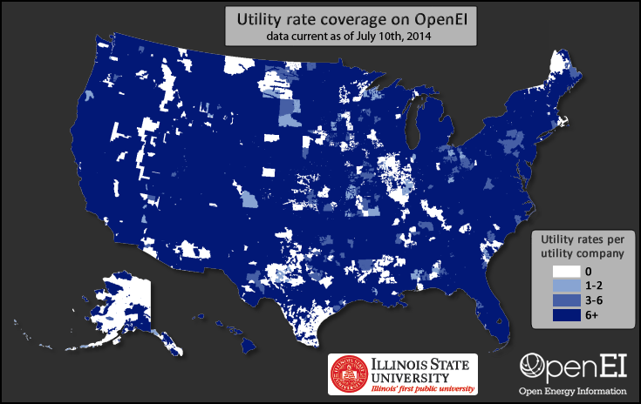

Figure 3. Geographic coverage of all rates in the URDB (Source: OpenEI 2014)

The first step in bill calculation involves automating the assignment of rates to agents in the model based on their location. When an agent qualifies for multiple rates within their assigned utility, a heuristic is used for selecting a single rate. Specifically, agents are limited to certain rates based on their sector (residential, commercial, or industrial) and electric use requirements (e.g., allowable demand ranges). Most of the URDB rate data do not include information about electric use requirements. Therefore, dGen uses only a subset of NREL-curated rates from the URDB, which include a set of rates for which NREL manually reviewed and added applicable demand ranges as well as a second set of rates for which each rate is the only available rate in its utility territory and sector. Combined, 2,370 rates from the URDB were curated for use in dGen, corresponding to utilities serving approximately 80% of residential and commercial load in the United States. Figure 4 shows the geographic coverage of the two combined subsets of rates extracted from the URDB for use in the model.

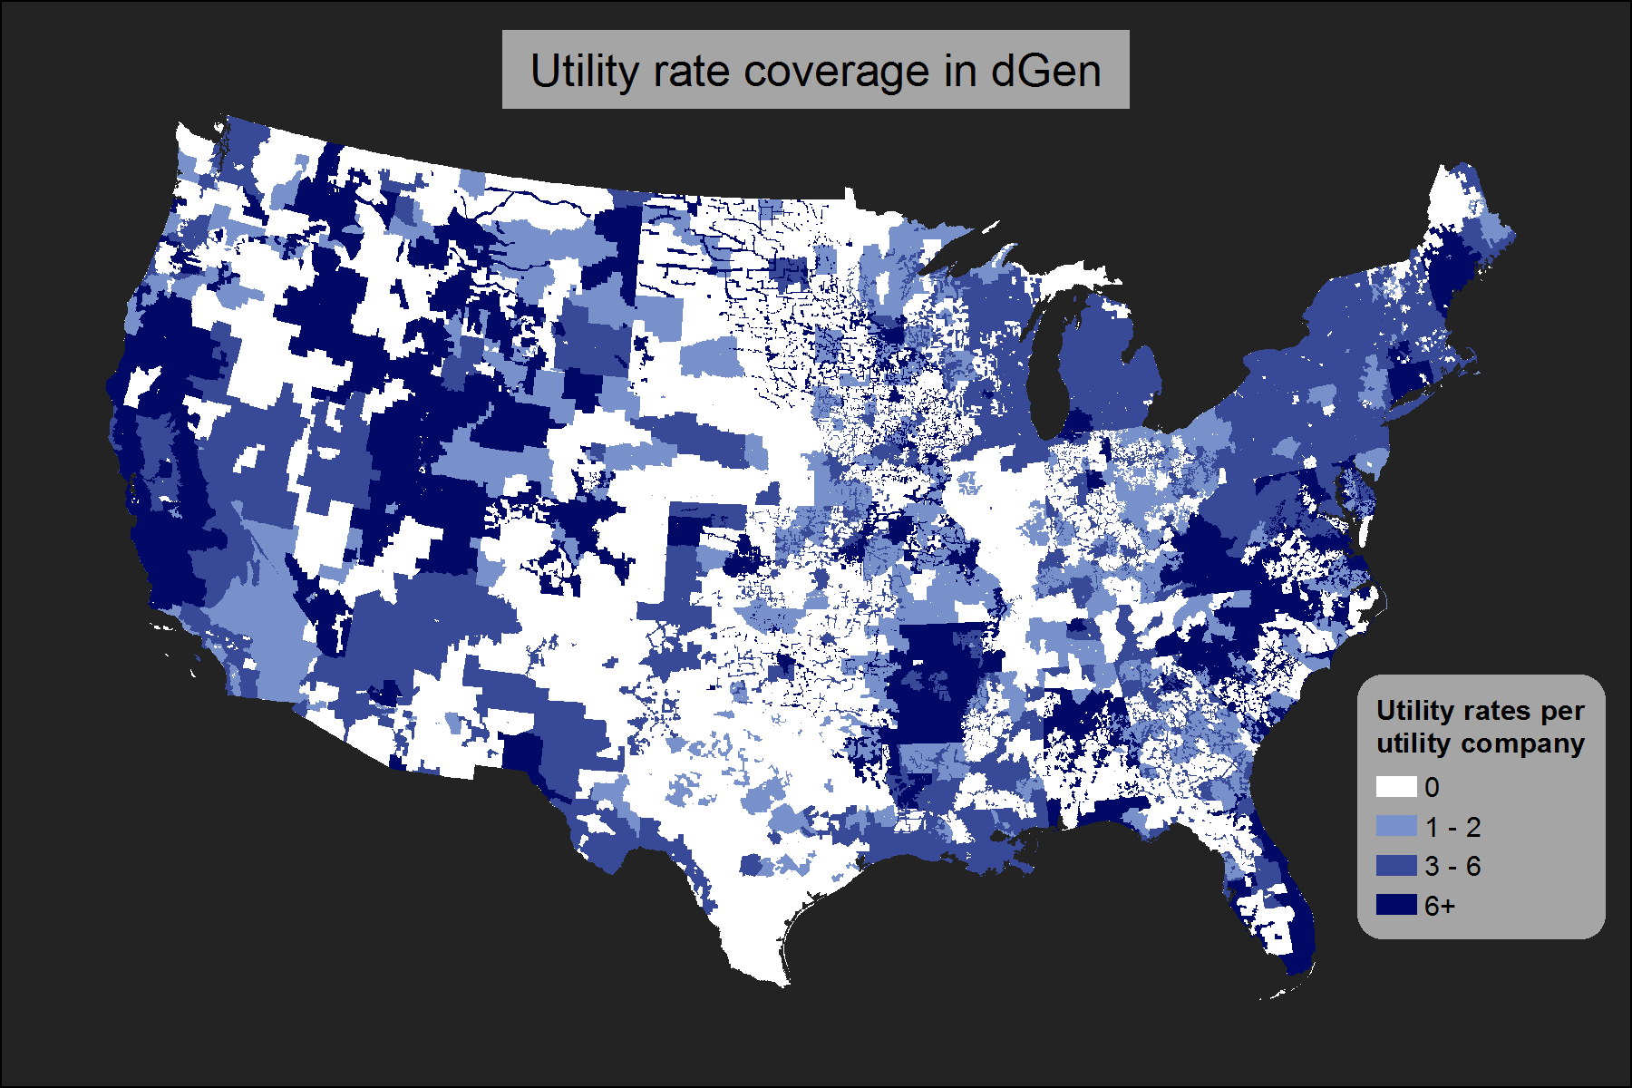

Figure 4. Geographic coverage of rates from URDB used in dGen (Source: OpenEI 2014)

For geographic regions lacking rate coverage, we developed a ranked backfilling methodology. In this ranking, priority is assigned in tiers. In the first tier, all rates associated with a utility territory within 50 miles of the agent location and matching the utility type (municipal, cooperative, investor-owned, or other) of the agent are ranked in order of distance from the agent location. For agents located in utility territories with rate coverage (as shown in Figure 4), these criteria automatically result in prioritizing the rates from the customer’s own utility territory; for customer locations without rate coverage, these criteria limit the influence of location-based drivers of differences in rates, such as differing climate and utility company structure. The remaining set of rates (i.e., rates that do not meet the two criteria) constitute the second tier of rates and are ranked purely using their proximity to the customer location. The two tiers of rate rankings are then consolidated, in order, into a single seamless set of rankings of potential rates for each customer location.

The rate rankings often include ties between rates from the same utility territory. Breaking of ties is dealt with dynamically within dGen. During each model run, a stochastic process is used to generate a set of customer types by sampling from customer locations and annual electric loads. Each customer type is also assigned a normalized annual electric load profile. Using this profile and the annual electric load of the customer, dGen determines the maximum demand required by the customer over the course of a typical year. This maximum demand is compared to the demand ranges associated with each of the curated URDB rate structures to filter out inapplicable rates. The remaining rate with the highest rank is then selected as the most applicable. If there is a tie among the most highly ranked rates, a weighted random sample is computed to determine the single rate to use for the customer. This random sampling process is performed independently for each customer with a tie in its most highly ranked rates; therefore, customers from the same region with the same rates may each end up with a different selected rate. The weights for random sampling are based on user-defined inputs that give the prevalence of different rate types by sector (Table 4). Values for these weights are estimates based on the judgment of NREL staff and do not have an empirical basis.

Table 4. User Input Table for Defining the Relative Prevalence of Different Rate Structures, by Sector

|  |  |  |
| --- | --- | --- |
| Elements of Rate | Residential | Commercial / Industrial |
| Flat | 0.2 | 0.05 |
| Demand | 0 | 0.2 |
| Seasonal | 0.2 | 0.05 |
| Tiered | 0.2 | 0.05 |
| Time of Use | 0.15 | 0.1 |
| Demand Tiered | 0 | 0.3 |
| Tiered Seasonal | 0.2 | 0.05 |
| Demand Time of Use | 0 | 0.15 |
| Other | 0.05 | 0.05 |
| Sum | 1 | 1 |

This random sampling approach for breaking ties is consistent with other techniques used in dGen. In the absence of better data or knowledge, we are uncertain which rate to use for certain customers. Therefore, rather than make a potentially incorrect or biased choice, the model allows users to apply a random sampling to investigate the effects of this uncertainty on model outputs. Nevertheless, this is a potential area for future model enhancement—a manual or semi-automated process could be performed to develop a more empirically founded ranking of rate prevalence or applicability within each utility area.

There are two important caveats to note about URDB rates used in dGen. First, because of project limitations, the URDB rates extracted are currently limited to residential and commercial sector rates. Industrial rates do exist in the URDB and may be added to dGen later as a model enhancement. In place of industrial rates, the current version of the model uses commercial rates to evaluate electric bills for industrial customers. Second, the data extracted from the URDB for the model represent a snapshot of real-world rate structures as of the time they were downloaded (December 2014). Finally, dGen assumes that rate structures do not change over time, although tariffs escalate over time using EIA forecasts (EIA 2015b) and the user may evaluate the effect of alternative rate structures through manual specification.

* + 1. Annual Average Flat Rates

For comparison, dGen allows users to calculate bill savings based on the average cost of electricity ($/kWh) by state. Although average rates represent overall energy expenditures for customers, by definition they do not incorporate important nuances in the DER value proposition, such as offsetting energy charges at higher tiers or reducing demand charges. These flat rates are derived from average retail price data by sector and utility territory provided by EIA (EIA 2015a). The rates are then mapped to counties using the utility territory to county lookup table included in the EIA 861 forms (EIA 2015c), as shown in Figure 5. For counties with multiple utility territories, a simple average rate from the overlapping utility territory rates was calculated.



Figure 5. Annual average electricity rates for residential customers by county (Source: EIA 2015a)

* + 1. User-Defined Flat Rates

As a final option, dGen users may also choose user-defined flat retail rates and can specify a unique rate for each state and sector. Default values in the input table for user-defined rates are based on the state annual average flat rates from 2012, as provided by EIA (EIA 2015a).

* 1. Excess Generation Value (Net Metering)

Depending on system configuration, imbalances in the temporal profiles of an agent’s system generation and energy consumption likely will result in times when generation that exceeds consumption must be exported to the electrical grid. Net metering is a billing mechanism that permits customers with grid-connected distributed generation to receive full retail credit for the energy the customers produce but do not consume. Although full-retail-credit net metering is available in multiple jurisdictions, it has provoked numerous regulatory disputes, and its future is uncertain. Reflecting this, dGen offers numerous options for valuing excess generation, including indefinitely continuing current policy (Barnes et al. 2013), valuing exported generation at the state wholesale electricity rate or avoided fuel cost of a natural gas combined-cycle generator, or a using a user-defined scenario.

Net metering configurations are defined in the input sheet by state, sector, outflow credit value (e.g., full retail rate, avoided fuel cost, none, or user-specified), and maximum system size that qualifies for the outflow credit. Users may also specify a transition period after which the “avoided cost” value will be used for all subsequent years (e.g., full credit through 2020, avoided cost credit for 2022‒2050).

* 1. Bill Savings Calculator

Agents receive value from DER system generation through two streams: value from offsetting energy consumption and value from selling excess generation back to the electrical grid. Both value streams are automatically calculated using the utilityrate3 module of the NREL System Advisor Model (SAM) (Blair et al. 2014) using the rates and excess generation values determined in Sections 4.4 and 4.5. Savings from offsetting energy consumption are based on a bottom-up calculation of the potential bill savings including, where applicable, fixed charges, seasonal rates, tiered rates, time-of-use (TOU) rates, and demand charges. Value from excess generation is based on the credit received for energy exported to the grid during hours when system generation exceeds consumption. The credit used for excess generation ranges from zero, when “No Net Metering” is selected, to full retail credit under the “Full Net Metering” option.

Including these two value streams, SAM calculates the agent’s annual electricity costs ($/year) with and without the proposed system. The difference of the costs is the cost savings (revenue) the agent would receive in the first year of system ownership. First-year bill savings are used as the basis for estimating bill savings over the system lifetime, subject to rate escalation forecasts (EIA 2014b) and system degradation. That is, it is assumed that rate changes and degradation will proportionally increase or decrease bill savings, which avoids recalculating exact bill savings for the entire system lifetime. Two assumptions implicit in the calculations are that retail rates and rate structures will not dramatically change over the system lifetime and that the agent’s adoption decision is based on their expectations *in the year they adopt.* In each year, non-adopters update their expectations based on changing conditions.

* 1. Value of Avoided Carbon Emissions

The potential impact of a carbon constraint and corresponding increase in the price of retail electricity can be considered in dGen. Because the future price of carbon is highly uncertain, the dGen default settings do not include a price for carbon emissions. However, users can specify the price of carbon emissions (in dollars per metric ton CO2) for each 2-year model time step. Setting a carbon price increases the assumed offset retail rate ($/kWh) as the product of the assumed carbon intensity (t CO2/kWh) and price ($/t CO2), thereby increasing the potential financial attractiveness of adopting.

Users have two options for estimating the carbon intensity of displaced electricity. They can use state-specific carbon intensity based on the local mix of fuels used to generate electricity or select a carbon intensity based on natural gas generation, which is frequently the marginal fuel in most electrical systems. Assuming the second approach, the retail adder for a carbon price range of $10–$50/t CO2 would be 0.4–2.1 ₵/kWh, respectively. These options allow users to quantify the sensitivity of distributed generation adoption to multiple carbon price scenarios.

* 1. Cash Flow Analysis

Combining the processes described above, dGen performs a detailed assessment of economic value using a formal cash flow analysis over the system lifetime for each remaining feasible system configuration. From the cash flows, a number of standard metrics are outputted, including net present value, internal rate of return, and payback period. These values are then used to calculate customer likelihood of adopting the technology, as described in Section 5.

The following six components determine annual cash flows:

1. **System payment**. For host-owned systems, the annual costs of servicing loans (principal repayment and interest) are based on the amount borrowed, loan term, and annual percentage rate; for TPO systems, the annual lease payments are used.
2. **Operation and maintenance costs**. These costs consist of variable ($/kWh) and fixed ($/kW/year) components.
3. **Revenue from generation**. The primary source of revenue is from generation, which offsets electricity costs, calculated as the sum of avoided consumption multiplied by the marginal avoided cost. Bill savings are calculated using the SAM utilityrate3 calculator, reflecting rate structure and excess generation credits as described previously. Revenue from generation is exactly calculated for the first year of system ownership and projected forward using assumptions about rate escalation and system degradation.
4. **Revenue from depreciation**. Commercial, industrial, and TPO agents may deduct asset depreciation over the system’s lifetime, which helps lower the agent’s tax burden. The depreciable basis is calculated as the installed cost of the system less half of any tax credits received. The depreciation schedule is selected by the model user. The available options include straight-line depreciation, the Modified Accelerated Cost Recovery System schedule, or a user-defined schedule.
5. **Revenue from interest deductions**. Owners of commercial, industrial and TPO systems are able to deduct the interest paid on the system from their taxable burden. Thus, interest deductions are a source of revenue at the specified taxable rate. The model assumes that the agent has a sufficient taxable burden to monetize interest deductions fully.
6. **Revenue from other incentives**. Agents can receive revenue from a variety of other incentive sources, including production-based incentives, production tax credits, tax credits, and rebates.
7. Modeling Market Diffusion

The diffusion of DER for each customer type is calculated in dGen by combining the economic attractiveness of potential adoption, as determined by the cash flow analysis (Section 4), with insights from the Diffusion of Innovations framework popularized by Bass (1969) and Rogers (2003). The framework posits that the diffusion of a novel technology occurs in an epidemic-like fashion, whereby the adoption pattern follows a logistic “S-curve” form (Figure 6). Furthermore, the rate of diffusion is initially slow, accelerating as additional customers consider the new technology.

A “market diffusion” or “S-curve” model is used in dGen to determine both the rate of technology uptake for different agent types as well as the maximum market size. Two outputs of this formulation are the market share (the cumulative fraction of eligible technologies that have already been adopted) and the maximum market share (the maximum fraction of eligible agents who would eventually adopt if economics remained unchanged). The general characteristics of the S-curve model are shown in Figure 6.

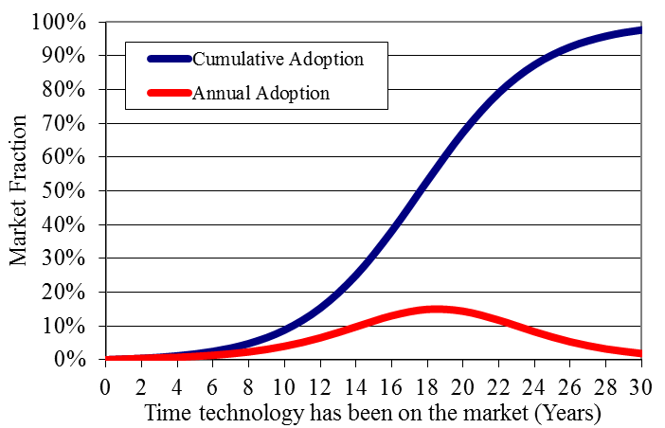

Figure 6. Annual and cumulative adoption rates simulated using the Diffusion of Innovation framework (Source: Bass 1969)

Each agent in the model represents a subset of customers in the overall DER market, and the specific attributes of that subset dictate how the technology diffuses into their subpopulation over time. This means that, although the adoption of DER technologies in dGen follows an S-shaped trajectory for the set of customers represented by an agent, the specific shape (e.g., maximum market and pace of adoption) of the adoption curve varies across customer types. The maximum market share is determined by the level of economic attractiveness for each agent (Figure 7). The pace of adoption is controlled by year-to-year changes in economics, with adoption accelerating if economics substantially improve.

The relationship between economic attractiveness and maximum market share has been quantified by several different sources, including NREL (Sigrin and Drury 2014), Navigant (Paidipati et al. 2008), EIA (2004), R.W. Beck (2009), and Kastovich et al. (1982) (Figure 7). Users of the model can select from these alternative estimates of maximum market share to investigate the effects on market diffusion. Current parameterization of the maximum market share assumes that, for host-owned systems, residential agents evaluate the economic attractiveness based on the system payback period (time to recoup the initial investment), whereas commercial and industrial customers use the internal rate of return. For leased systems with no upfront cost, agents evaluate adoption using their monthly net bill savings (i.e., bill savings minus the lease payment) as a fraction of their summer bills prior to adoption using the market share curves published by Sigrin and Drury (2014) (not pictured here).

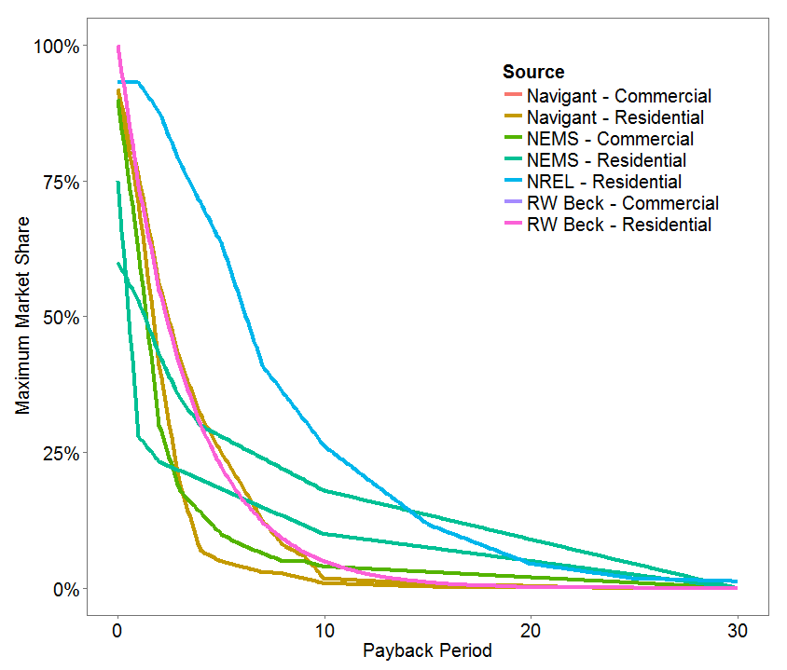

Figure 7. Maximum market share as a function of payback period based on different sources (Source: R.W. Beck 2009; EIA 2004; Paidipati et al. 2008; Sigrin and Drury 2014)

* 1. Business Model Selection

For agents with the ability to adopt via host or third-party ownership, dGen can evaluate both options and select the business model that is more economically attractive as measured by the maximum market share. Users of dGen can further define the decision-making criteria using the “ranking” method, whereby agents select the business model with the larger maximum market share, or the “probabilistic” method, which assumes some fraction of agents will select the economically inferior business model. In the probabilistic method, the probability of an agent selecting the leasing model $(P_{l})$ is defined using a standard logit equation:

$P_{l}= \frac{M_{l}^{α}}{M_{l}^{α}+M_{b}^{α}} (1)$

where $M_{l}$ and $M_{b}$ are the maximum market shares of the leasing and buying models, respectively, and α is a segregation parameter with a default value of two. In this formulation, the agent is indifferent to either model when both models provide equal economic benefits, but it is likely to prefer the business model with superior economics.

* 1. Market Diffusion

The model is initialized with historical diffusion levels consistent with 2013 market conditions. At each subsequent time step, historical diffusion levels are updated to reflect the incremental diffusion during the previous time step, and financial calculations are updated to reflect changing market and technology factors. Basic exemption handling ensures that previously installed systems are not removed if the market drops and that growth in population and load does not distort historical diffusion levels. The model tracks adoption levels—including new customers, installed capacity, and overall wind market value—over all model years to capture the cumulative adoption for each from 2014 through 2050, and agents are aggregated together to capture the overall diffusion of each DER technology in the state and national markets. To accomplish this, the following specific formulation can be used.

Let S and M be the market share and maximum market share calculated for year t for agent i. First calculate the p & q parameters for the Bass model, with a default value for p = 0.0015 and q defined as:

q = 0.5 if payback period < 3 years or percent monthly bill savings > 180%

q = 0.4 if payback period in (3, 10 years] or percent monthly bill savings in [133%, 180%)

q = 0.3 if payback period in (10, 30 years] or percent monthly bill savings in [0%, 133%).

A complication of using multiple S-curves is transitioning from one curve to another when DER economics change with cost reductions, electricity rate changes, or other factors. Because the market-penetration fraction scales the total deployment, this transition would lead to a step increase in adoption in the year that the model switched from one curve to another. To smooth this transition, we calculate the position on the new S-curve by solving for the “equivalent year” ($t_{eq}$) the technology has been in the market, which as calculated as $:$

$$t_{eq}=\frac{\ln{\frac{\left(1-ratio\right)}{1+\left(ratio\right)*(\frac{q}{p})}}}{-(p+q)} (2)$$

where ratio is shorthand for $\frac{M_{t-1}}{M_{t}}$.

Then, stepping forward 2 years from the equivalent time, dGen calculates the new adoption fraction in time t ($A_{t}$) using the classic Bass diffusion as:

$$A_{t}=\frac{1-e^{-\left(p+q\right)*teq+2} }{1+\left(\frac{q}{p}\right)e^{-\left(p+q\right)*teq+2}} (3)$$

Finally, calculate the market share rate (S) as:

$$S_{t}=M_{t}*A_{t } (4)$$

where market share cannot decline from the previous year’s level (which would imply systems are uninstalled):

$S_{t}=Max(S_{t-1}, S_{t})$.

References

AWST (AWS Truepower, LLC) (2012a). “3% Gross Capacity Factor TMY Profile at 20 km Locations.”

AWST (AWS Truepower, LLC) (2012b). “IEC Class II Annual Gross Capacity Factor at 80 m”.

Barnes, Justin, Culley, Thad, Haynes, Rusty, Passera, Laurel, Wiedman, Joseph, and Jackson, Rosalind. 2013. *Freeing the Grid 2013: Best Practices in State Net Metering Policies and Interconnection Procedures*. Interstate Renewable Energy Council. Accessed July 7, 2014: <http://freeingthegrid.org/wp-content/uploads/2013/11/FTG_2013.pdf>.

Bass, F. (1969) “A New Product Growth for Model Consumer Durables,” *Management Science* 18: 215‒227.

Blair, N., Dobos, A., Freeman, J., Neises, T., Wagner, M., Ferguson, T., Gilman, P., Janzou, S. (2014). System Advisor Model, SAM 2014.1.14: General Description. NREL/TP-6A20-61019. February 2014

Davidson, C., Margolis, R. (2015) Selecting Solar: Insights into Residential Photovoltaic (PV) Quote Variation. NREL/TP – 6A20 – 64792. *Forthcoming*

Denholm, P.; Drury, E; and Margolis, R. (2009a). *The Solar Deployment Systems (SolarDS) Model: Documentation and Sample Results*. NREL/TP-6A2-45832. Golden, CO: National Renewable Energy Laboratory. Accessed September 24, 2014: <http://www.nrel.gov/docs/fy10osti/45832.pdf>.

Denholm, P.; Margolis, R.; Milford, J. (2009b). “Quantifying Avoided Fuel Use and Emissions from Solar Photovoltaic Generation in the Western United States.” Environ. Sci. Technol. (43); pp. 226-232.

Dobos, A. (2015). *PVWatts Version 5 Manual.* NREL/TP-6A20-62641. Golden, CO: National Renewable Energy Laboratory. <http://www.nrel.gov/docs/fy14osti/62641.pdf>

DOE (U.S. Department of Energy). 2012. *The SunShot Vision Study*. DOE/GO-102012-3037. Washington, DC.

DOE (U.S. Department of Energy). (2015). *[WindVision: A New Era for Wind Power in the United States](http://energy.gov/windvision)*. DOE/GO-102015-4557. Washington, DC.Dragoon, K., and Dvortsov, V. (2006). “Z-Method for Power System Resource Adequacy Applications.” *IEEE Transactions on Power Systems* 21 (2): 982–88. doi:10.1109/TPWRS.2006.873417.

Drury, E.; Miller, M.; Macal, C.; Graziano, D.; Heimiller, D.; Ozik, J.; and Perry IV, T. (2012). [The Transformation of Southern California's Residential Photovoltaics Market through Third-Party Ownership](http://www.sciencedirect.com/science/article/pii/S0301421511010536). *Energy Policy*. Volume 42, March 2012, Pages 681–690.

Drury, E.; Denholm, P.; and Margolis, M. (2013). *Sensitivity of Rooftop PV Projections in the SunShot Vision Study to Market Assumptions*. NREL/TP-6A20-54620. Golden, CO: National Renewable Energy Laboratory. Accessed September 24, 2014: <http://www.nrel.gov/docs/fy13osti/54620.pdf>.

DSIRE (Database of State Incentives for Renewables & Efficiency) (2014) “Database of State Incentives for Renewables & Efficiency,”. Accessed January 15, 2014, [www.dsireusa.org](http://www.dsireusa.org).

EIA (U.S. Energy Information Administration). (2014a) 2009 Residential Energy Consumption Survey Data, accessed March 2, 2014, <http://www.eia.gov/consumption/residential/data/2009/index.cfm?view=microdata>.

EIA (U.S. Energy Information Administration). (2014b). *Annual Energy Outlook 2014 with Projections to 2040*. Washington, DC: DOE.

EIA (U.S. Energy Information Administration). (2004). *The electricity market module of the National Energy Modeling Systems: Model Documentation Report*. DOE/EIA-M068. Washington, DC: DOE.

EIA (U.S. Energy Information Administration). (2008). 2003 Commercial Building Energy Consumption Survey (CBECS) Public Use Microdata. Accessed March 2, 2014: <http://www.eia.gov/consumption/commercial/data/2003/index.cfm?view=microdata>.

EIA (U.S. Energy Information Administration). (2015a) *Detailed State Data: Average Price by State by Provider (EIA-861)*. Accessed January 2, 2015, <http://www.eia.gov/electricity/data/eia861/>.

EIA (U.S. Energy Information Administration). (2015b). *Electric power sales, revenue, and energy efficiency Form EIA-861 detailed data files*. Accessed December 15, 2013, <http://www.eia.gov/electricity/data/eia861/>.

Elliott, D.L., C.G. Holladay, W.R. Barchet, H.P. Foote, and W.F. Sandusky (1986). Wind energy resource atlas of the United States. <http://rredc.nrel.gov/wind/pubs/atlas/>

Funkhouser, E.; Blackburn, G; Magee, C.; Rai,V. (2015). Business Model Innovations for Deploying Distributed Generation: The Emerging Landscape of Community Solar in the U.S. *Energy Research & Social Science* 10 (November): 90–101. doi:10.1016/j.erss.2015.07.004.

Gagnon, P., R. Margolis, J. Melius, C. Phillips, and R. Elmore. (forthcoming) *Rooftop Photovoltaic Technical Potential in the United States: A Detailed Assessment*. NREL Technical Report. NREL/TP-6A20-XXXXX. Golden, CO: National Renewable Energy Laboratory.

George, R., Wilcox, S.; Anderberg, M.; and Perez, R. (2007). “National Solar Radiation Database (NSRDB) - 10 km Gridded Hourly Solar Database.” Proceedings of Solar 2007, Cleveland, OH, Published by the American Solar Energy Society.

Hand, M.M., Baldwin, S., DeMeo, E., Reilly, J.M., Mai, T., Arent, D., Porro, G., Meshek, M., Sandor, D. 2012. *Renewable Electricity Futures Study*. NREL/TP-6A20-52409. Golden, CO: National Renewable Energy Laboratory. <http://www.nrel.gov/analysis/re_futures/>.

HSIP (Homeland Security Infrastructure Program) (2012). “HSIP Gold 2012 Infrastructure ArcGIS 9.3 Filebase Geodatabases”

Jin, S., Yang, L., Danielson, P., Homer, C., Fry, J., and Xian, G (2013). “A comprehensive change detection method for updating the National Land Cover Database to circa 2011”. *Remote Sensing of Environment*, 132: 159 – 175.

Kastovich, J.C., Lawrence, R.R., Hoffmann, Pavlak, C. 1982. *Advanced Electric Heat Pump Market and Business Analysis*. ORNL/Sub/79-2471/1. Prepared under subcontract for Oak Ridge National Laboratory by Westinghouse Electric Corp. Oak Ridge, TN: Oak Ridge National Laboratory.

Kellndorfer, J., Walker, W., LaPoint, E., Bishop, J., Cormier, T., Fiske, G., Hoppus, M., Kirsch, K., and Westfall, J. (2012). “NACP Aboveground Biomass and Carbon Baseline Data (NBCD 2000), U.S.A., 2000”. Available on-line at http://daac.ornl.gov from ORNL DAAC, Oak Ridge, Tennessee, U.S.A.

Mills, A.; Wiser, R. (2012). An Evaluation of Solar Valuation Methods Used in Utility Planning and Procurement Processes. LBNL-5933E. Berkeley, CA: Lawrence Berkeley National Laboratory

MRLC (Multi-Resolution Land Characteristics Consortium) (2001). “National Land Cover Database 2001”. Accessed December 15, 2013, <http://www.mrlc.gov/nlcd01_data.php>.

NSRDB (National Solar Radiation Database) (2015) <http://rredc.nrel.gov/solar/old_data/nsrdb/>. Accessed July 15, 2015.

OpenEI. (2014). U.S. Utility Rate Database. Accessed December 15, 2014. http://en.openei.org/wiki/Utility_Rate_Database

ORNL (Oak Ridge National Laboratory) (2011). “Landscan USA™ Raster Datasets (2011‑Prerelease)”.

Paidipati, J., Frantzis, L., Sawyer, H., Kurrasch, A. (2008). *Rooftop Photovoltaics Market Penetration Scenarios*. Subcontract Report NREL/SR-581-42306. Burlington, MA: Navigant Consulting.

PNNL (Pacific Northwest National Laboratory). (2012). GCAM Documentation Wiki. PNNL/20809. Accessed January 2013: http://wiki.umd.edu/gcam/index.php/Main_Page

Rai, V; Sigrin, B. (2013). [Diffusion of environmentally-friendly energy technologies: buy versus lease differences in residential PV markets](http://iopscience.iop.org/1748-9326/8/1/014022). *Environ. Res. Lett.* 8 014022

Rogers, E. (2003) *Diffusion of Innovations*. 5th edition. (New York: Free Press, 2003).

R.W. Beck Inc. 2009. *Distributed Renewable Energy Operating Impacts and Valuation Study*. Prepared for Arizona Public Service

Satchwell, A; Mills, A.; Barbose, G. (2015a). Quantifying the Financial Impacts of Net-Metered PV on Utilities and Ratepayers. *Energy Policy* 80 (May): 133–44. doi:10.1016/j.enpol.2015.01.043.

Satchwell, A; Mills, A.; Barbose, G. (2015b). Regulatory and Ratemaking Approaches to Mitigate Financial Impacts of Net-Metered PV on Utilities and Ratepayers. *Energy Policy* 85 (October): 115–25. doi:10.1016/j.enpol.2015.05.019.

Short, W., Sullivan, P., Mai, T., Mowers, M., Uriarte, C., Blair, N., Heimiller, D., and Martinez, A. 2011. *Regional Energy Deployment System (ReEDS)*. NREL/TP-6A20-46534.National Renewable Energy Laboratory (NREL), Golden, CO (US). <http://www.nrel.gov/analysis/reeds/pdfs/reeds_documentation.pdf>.

Sigrin, B. Drury, E. (2014). Diffusion into New Markets: Economic Returns Required by Households to Adopt Rooftop Photovoltaics. *AAAI Energy Market Prediction Symposium*. Washington, November 13-15, 2014.

Sigrin, B.; Sullivan, P.; Ibanez, E.; Margolis, R. (2014). [Representation of Solar Capacity Value in the ReEDS Capacity Expansion Model](http://www.nrel.gov/docs/fy14osti/61182.pdf). 25 pp.; NREL Report No. TP-6A20-61182. March.

Sullivan, P.; Cole, W.; Blair, N.; Lantz, E; Krishnan, V.; Mai, T.; Mulcahy, D.; Porro, G. (2015). 2015 Standard Scenarios Annual Report: U.S. Electric Sector Scenario Exploration. NREL/TP-6A20-64072. Golden, CO: National Renewable Energy Laboratory.

U.S. Bureau of the Census (1994). *Geographic Areas Reference Manual*. U.S. Dept. of Commerce, Economics and Statistics Administration, Bureau of the Census. Accessed May 1, 2015: https://www.census.gov/geo/reference/garm.html.

Ventyx. (2012). “Velocity Suite: Electric Company Retail Sales Data – Combined by Company”.

Appendix A. Rooftop Photovoltaic Information

A1. Solar Resource

Solar resource in dGen is based on the National Solar Radiation Database (NSRDB) 10 km Gridded Hourly Solar Database (George et al. 2007). This database consists of hourly solar radiation estimates for approximately 91,500 grid cells covering the 48 contiguous states and Hawaii at a spatial resolution of roughly 10 km (Figure 8). The hourly radiation values for each grid cell in this database are representative of a typical meteorological year, derived from satellite modeled data from 1998 through 2005.

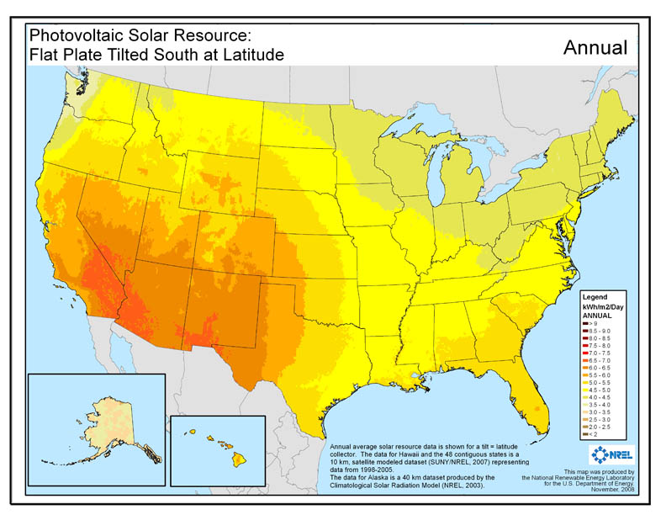

Figure 8. Map of PV resource derived from NSRDB 10 km Gridded Hourly Solar Radiation Database[5]

To simulate U.S. PV energy production, we applied the SAM PVWatts (Version 5) module (Dobos 2015) to the hourly solar radiation data for each 10 km grid cell. At each location, we modeled a 1-kW capacity, rooftop PV system for a wide variety of rooftop orientations (tilt and azimuth), including a combination of six tilts (5, 15, 25, 35, 45, and 55 degrees) and five azimuths (west, southwest, south, southeast, and east) as well as south-facing and tilted at latitude. Using this combination of 31 distinct orientations for each of the 91,500 NSRDB grid cells gives dGen access to annual and hourly electricity generation simulations for more than 2.8 million distinct rooftop PV system configurations across the United States, where agents at the 200m level are mapped to one of these simulations based on location and likely system configuration.

A2. Rooftop Technical Potential

To capture regional variation in the configuration of rooftop orientations and their availability and suitability for PV development in dGen, we draw upon and extend work by our colleagues (Gagnon et al. 2015). This discussion provides a brief background of Gagnon et al. (2015) and then an in-depth description of the methods we have used to build upon their work in order to integrate the following components of rooftop PV technical potential into dGen:

1. Top-down constraints on the rooftop area suitable for PV development by region, and
2. Bottom-up representations of the variation in rooftop configurations (azimuth, tilt, area), also by region.

A2.1 Background

Gagnon et al. (2015) present methods used to characterize the configuration of rooftops for 128 U.S. cities based on light detection and ranging (LiDAR) data and then apply the results within a modeling framework to predict the total technical potential for rooftop PV. The LiDAR data used in their work included high-resolution (1-m by 1-m) digital surface models (DSMs) and building footprint polygons derived from aerial LiDAR surveys performed by the U.S. Department of Homeland Security (DHS) Homeland Security Infrastructure Program (HSIP) between 2006 and 2014. The full dataset covers 1.5% of mainland U.S. land area, 33% of the U.S. population, 26.9 million buildings, and 7.7 billion m2 of rooftop area.

Using these datasets, the authors performed a series of GIS analyses to isolate individual roof planes and determine their suitability for PV development based on size, tilt, azimuth, and shading during different times of year. Suitability is treated by the authors as a Boolean variable of either developable or undevelopable. Using the outputs of this analysis, along with ancillary geospatial datasets, the authors then build, train, and apply predictive models to estimate the rooftop suitability and total technical potential for areas beyond the 128 cities. These predictive models are performed separately for three different building size classes defined by the authors: small (< 5,000 sq. ft.), medium (5,000 to 25,000 sq. ft.), and large (≥ 25,000 sq. ft). The authors provide the resulting PV technical potential estimates by zip code (for small buildings) and Census Region or state (for medium and large buildings).

For dGen, we applied and extended the work by Gagnon et al. (2015) for two distinct purposes. First, we applied their regional predictions of developable rooftop area as an overall, top-down cap on the allowable deployment of PV systems over time. Second, we performed additional analysis on the subset of developable rooftop planes for the 128 LiDAR cities to determine regional variation in the frequency of various rooftop configurations and sizes across the United States. These regional differences in rooftop characteristics are applied in dGen to stochastically parameterize model agents with system orientations and sizes. In comparison to the top-down technical potential caps, these frequencies of rooftop configurations provide more of a bottom-up integration of regional rooftop variation into the model.

A2.2 Technical Potential Caps

As noted in the previous section, dGen incorporates the predictions of total developable rooftop area from Gagnon et al. (2015) as caps on PV deployment. These caps constrain the cumulative PV deployment that can occur in a dGen simulation over time but will generally only have an effect on deployment levels when the model scenario is highly favorable for growth in the PV market. The technical potential limits are initialized during the first model year (2014), equal to the developable rooftop area predicted by Gagnon et al. (2015) and scaled linearly over time in equal proportion to load and customer growth. Area is used, rather than capacity, to accommodate improvements in PV panel performance over time.

The caps are applied in the model separately for each building footprint size class. Each agent in the model is parameterized with annual electric consumption data from the RECS and CBECS microdata (EIA 2008; EIA 2014a). Although neither of these microdata sets provide information on building footprint area, we calculate an estimate of building footprint area for each building in the microdata by dividing the building’s total square footage by its number of floors. We then classify these estimates into the same building size classes used by Gagnon et al. (2015) and track deployment of PV over all agents in each region by each building size class, ensuring that deployment does not exceed the total developable area estimated by Gagnon et al. (2015).

For simplicity, dGen tracks cumulative deployment and technical potential limits for all building size classes at the state-level resolution. We therefore aggregate zip code level results for small buildings from Gagnon et al. (2015) to states and use the authors’ population-weighted state-level estimates for medium and large buildings. In the former case, aggregation to states likely lowers uncertainty in the predicted technical potential limits. In the latter case, the authors predicted estimates at the Census Region level and then used a simple population-weighted disaggregation to calculate state-level estimates.

A2.3 Regional Variation in Rooftop Configuration

In order to parameterize agents in dGen with rooftop configurations appropriate for their region, customer sector, and electricity usage, we extended the analysis by Gagnon et al. (2015) to derive datasets describing the frequency of various rooftop configurations. The outcome of this analysis is a discrete multivariate distribution of optimal developable roof planes by azimuth, slope, and area class for each region, customer sector, and building size class, which we then interpolated to non-sampled regions. This analysis involved five steps:

1. Identifying building use types aligned with dGen customer sectors (i.e., residential/non-residential)
2. Deriving the percent of buildings with at least 10 m2 developable roof area[6] by building use and size class
3. Ranking the suitability for PV of developable roof planes on each building based on the size of the plane, the size of the building footprint, and the expected annual generation of a roof-mounted PV system
4. Consolidating the developable roof planes for each building to a single orientation representing the “optimal only” or “optimal blended” plane
5. Deriving a discrete multivariate distribution of optimal roof planes by azimuth, slope, and area class for each region, customer sector, and building size class

These data are then implemented in the agent generation stage highlighted in Section 2 to represent rooftop orientation accurately at the individual agent level.

A2.3.1 Identification of Building Use

The model simulates PV deployment for three customer sectors: residential, commercial, and industrial. Because the structural design of buildings used by these sectors can vary significantly, our first step in characterizing regional variation in rooftop configurations was to classify the use type for each of the LiDAR buildings analyzed by Gagnon et al. (2015). In preliminary analyses, we found that distinguishing between commercial and industrial use types proved intractable; therefore, our analysis resulted in classification of buildings as either residential or nonresidential.

The methodology we developed to classify building use (residential or non-residential) for each building in the LiDAR data incorporated three predictive variables: building footprint size, estimates of the daytime to nighttime population ratio near the building (ORNL 2011), and distances from known residential/non-residential point sources (HSIP 2012). The three variables were combined in a weighted index that predicted the building use based on the overall score (Figure 9, Figure 10, and Figure 11).

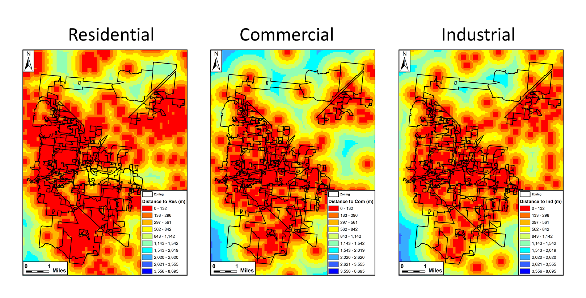

Figure 9. Distance to the nearest residential, commercial, and industrial presence cells, respectively; each building received a score of 1 for either residential or 1 for non-residential (commercial/industrial) based on whichever building use had the smaller distance

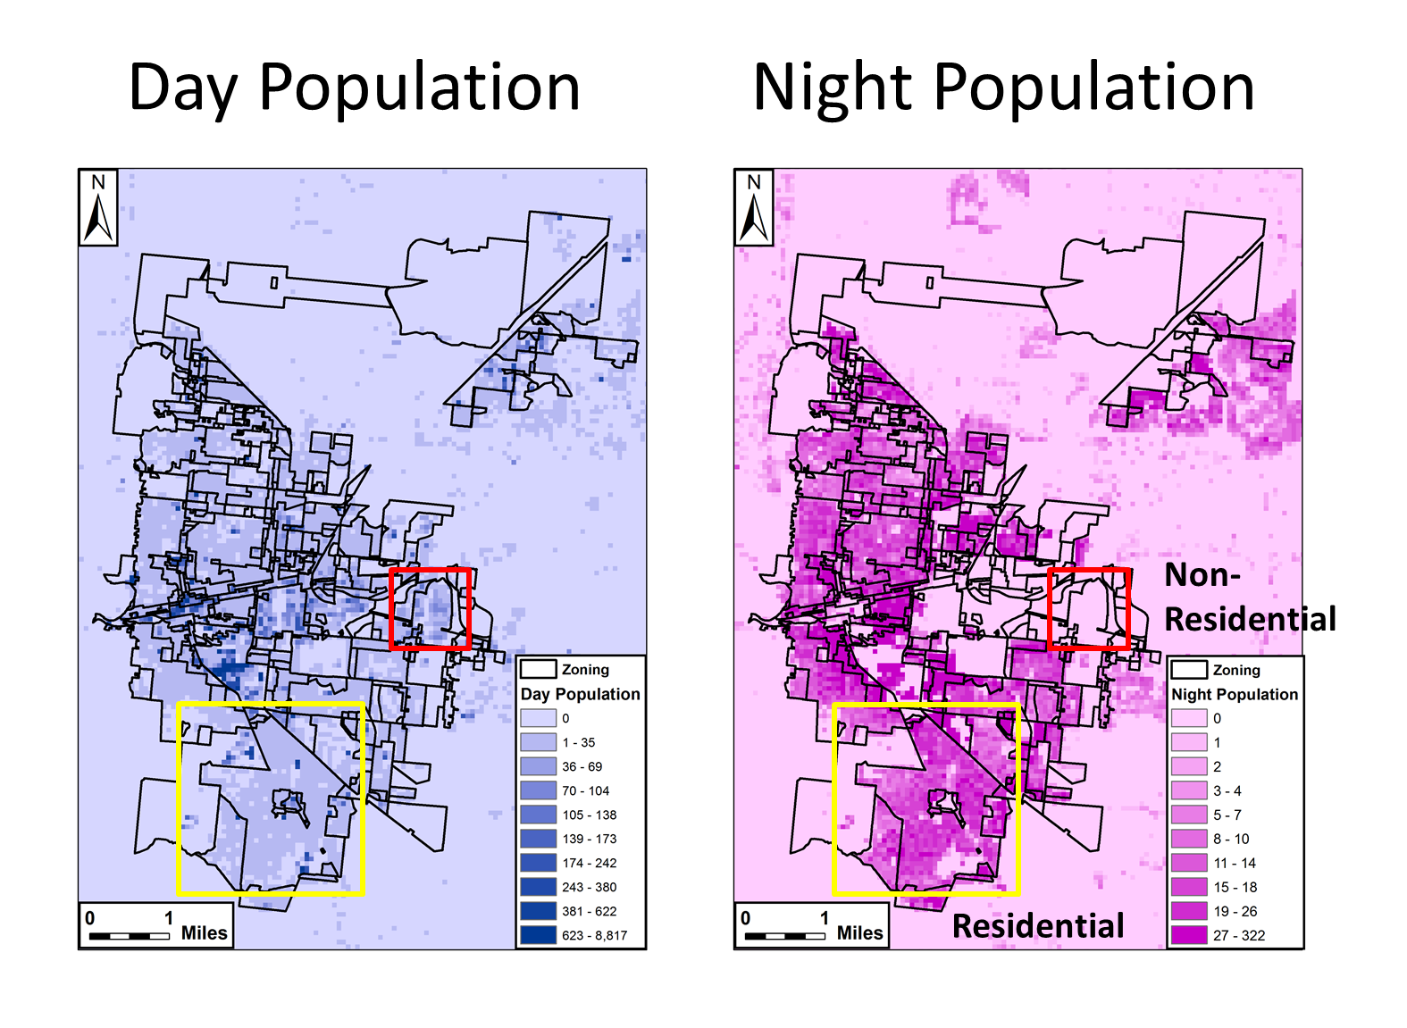

Figure 10. Daytime and nighttime population in Boulder, CO; buildings were given a score of 1 for residential where the nighttime population was greater than the daytime population and a score of 1 for non-residential where the daytime population was greater than the nighttime population

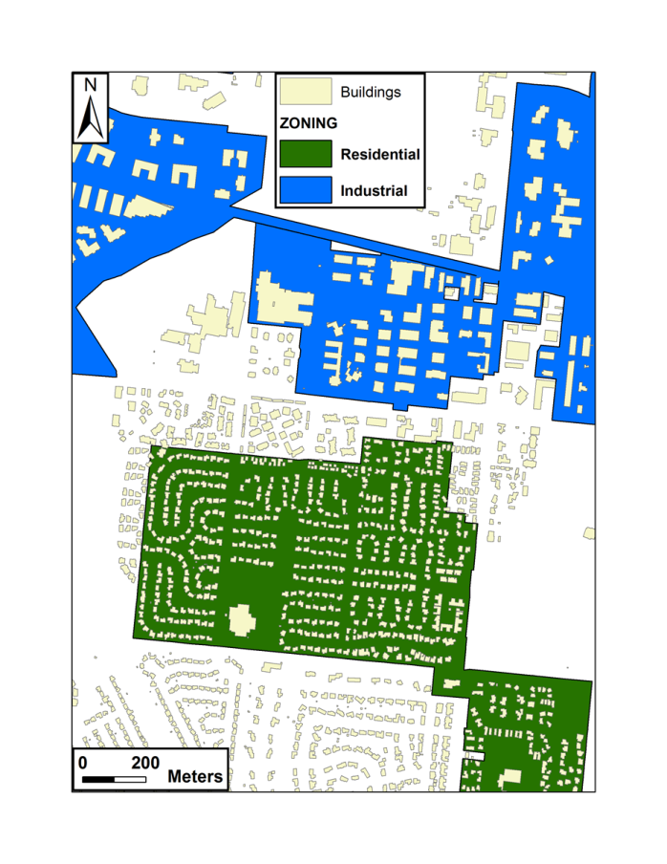

Figure 11. Building footprint size can be used as a predictor of building use, as smaller buildings tend to be residential (green area), and larger buildings tend to be non-residential (blue area); an area of Boulder, CO is shown as an example

The building use classification model was trained using a cross-validation method for three cities of varying population and urban characteristics (Baltimore, MD; Minneapolis, MN; and Boulder, CO), where true building use was extracted from zoning polygon shapefiles downloaded from each of the city’s websites, for each building location. The classification model was trained to determine the breakpoints in the building footprint size classification as well as the relative importance of each contributing dataset (footprint size, daytime ratio, and distance to known establishments) to the overall classification. The final model specification was based on minimizing the error between modeled and actual classification, averaged over the three cities to avoid overfitting. Specifically, average accuracy is determined from user accuracy (Equation A1) and producer accuracy (Equation A2) for both residential and non-residential classes for each training city as described in Equation A3.

User Accuracy = $\frac{\# Correct Residential}{\# Classified as Residential}$ X 100 (A1)

Producer Accuracy = $\frac{\# Correct Residential}{Total \# of Residential}$ X 100 (A2)

Average Accuracy = $\frac{Res User+Res Producer+Non Res User+Non Res Producer}{4}$ (A3)

Finally, we validated the classification model against zoning data for three additional cities (Charlotte, NC; Helena, MT; and San Francisco, CA) to assess the overall accuracy. Only buildings in areas zoned for purely residential or purely non-residential purposes were used in the accuracy assessment, and the accuracy of mixed zones was not assessed. Overall accuracy of the model was high, at 84.99% (Table 5, Figure 12); buildings that were classified incorrectly were generally located in small zones because of the coarse cell size of the input datasets. In all three cities, the lowest accuracy was the producer accuracy of non-residential buildings, suggesting that the model is too conservative in the predictions of non-residential buildings.

Table 5. Summary of Building Use Classification Model

|  |  |  |
| --- | --- | --- |
| **Average Non-Residential**  **Building Use Accuracy** | **Average Residential**  **Building Use Accuracy** | **Overall Average Accuracy** |
| **83.65%** | **86.33%** | **84.99%** |

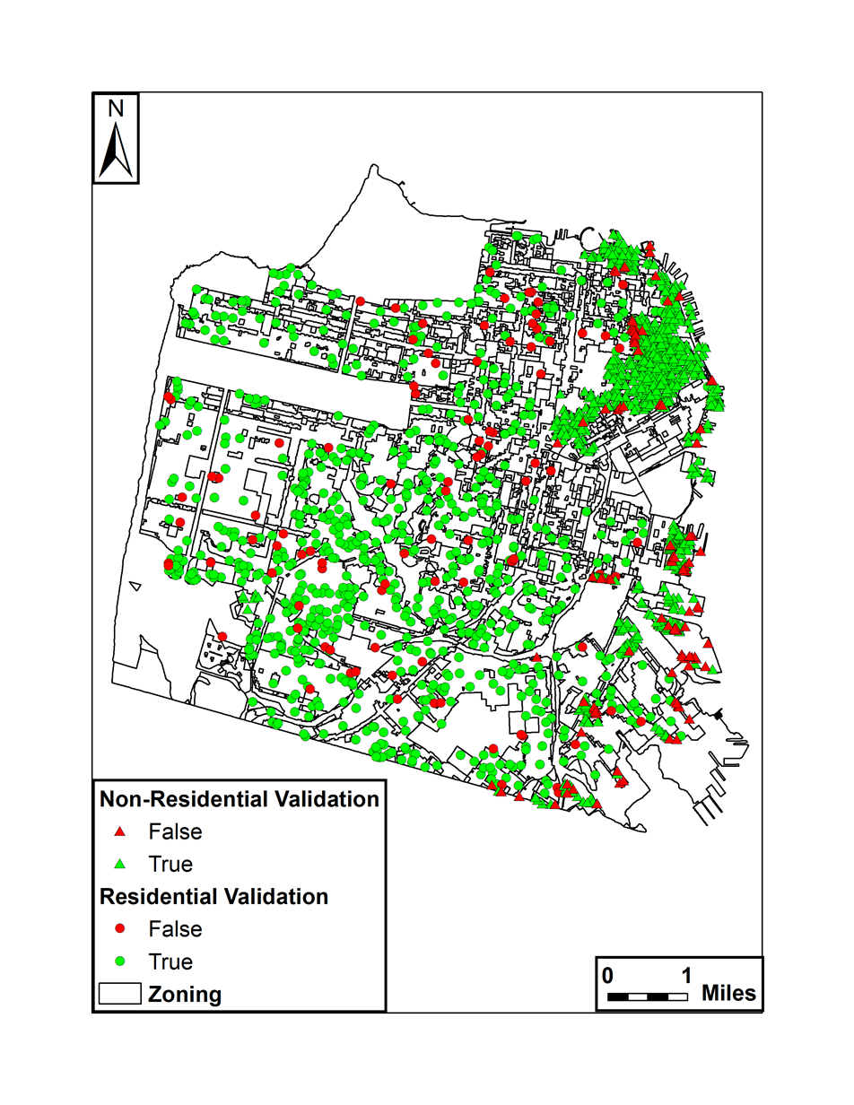

Figure 12. Map illustrating the accuracy of classifying residential and non-residential buildings in San Francisco, CA

We applied the trained classification model to every building in the LiDAR dataset, resulting in a classification of building use type for the 128 cities in the LiDAR data. The classification was applied to buildings in non-sampled areas based on locales using the nearest city.

A2.3.2 Identifying Percent of Undevelopable Buildings

For each of the 128 cities in the LiDAR dataset, we calculated the percent of buildings with at least one developable roof plane by building use type and footprint size class (small, medium, or large). A “developable” roof plane is defined in Gagnon et al. (2015) as having at least 10m2 of roof area which is 1) at least 80% unshaded, and 2) not oriented NW, N, or NE. This area is roughly equivalent to a 1.5 kW c-Si system using currently available technology. These estimates of the percent of undevelopable buildings are applied to each agent in dGen, according to their sector and building size class, to determine the portion of customers who are entirely restricted from rooftop PV adoption.

A2.3.3 Ranking Rooftop Suitability

For each building in the LiDAR dataset, we ranked the suitability of its roof planes for PV development. These rankings are based on the area and expected annual generation of each plane and the size of the building footprint, which is used as a proxy for electricity demand.

In order to rank the roof planes, we performed the following preprocessing steps:

* Reclassify the continuous slope and azimuth values for each developable LiDAR roof plane to a discrete set of 31 combinations of slope and azimuth, corresponding to the combinations used in PV system generation modeling.
* Group all planes with like orientations on the same building into a “composite plane” and calculate their aggregate area.
* Link each composite plane to the most appropriate estimate of PVWatts simulated annual energy production for a 1-kW PV system based on location, azimuth, and tilt.

Using the expected energy production and aggregate area, we ranked the set of eligible planes for each building to determine the optimal developable composite plane for the building. Our ranking method assumed that building owners would prioritize efficiency of energy production on large roof planes (to get the most production per unit cost) and, secondarily, prioritize absolute energy production on small planes (to maximize production).

To match this heuristic, rankings were calculated in a stepwise fashion. First, all composite planes occupying greater than 10% of the building’s footprint were ranked in descending order by PV efficiency (kWh per kW). Second, all remaining small planes were ranked in descending order based on the product of PV efficiency and roof plane area. The two sets of ranks were then merged, in order, to create one seamless set of rankings.

A2.3.4 Consolidating to “Optimal” Roof Planes

Due to computational limits and performance considerations, agents in dGen are constrained such that each agent can only consider the economics for a PV system where all panels share a single, uniform orientation (i.e., one tilt and one azimuth). As a result, in order to parameterize agents based on rooftop configurations derived from the LiDAR dataset, each LiDAR building with multiple developable roof planes needs to be simplified to a representation of a single roof plane. Because there is no straightforward way to perform this simplification without inherently losing some fidelity and introducing bias into the model, we performed two different approaches and allow users of dGen to choose between them to perform sensitivity analyses.

The two approaches we used are:

1. Optimal Only: Select only the single “optimal” developable roof plane for each building and ignore all other roof planes.
2. Optimal Blended: Treat all developable roof planes as if they shared the orientation of the “optimal” roof plane, discounting their areas in proportion to their capacity factors.

For both of these approaches, we first used the suitability rankings, described in Section A2.3.3, to select the highest ranked composite plane for each building as the optimal developable plane. For the Optimal Only approach, we simply filtered out all other roof planes, as if the developable area of each building only consists of its optimal plane. For the Optimal Blended approach, we calculated the ratio of the modeled energy production for each suboptimal composite plane to that of the optimal composite plane, applied that ratio to discount the area of each suboptimal plane, and then summed all areas. For each approach, we then proceeded to derive (separate) regional frequencies of rooftop configurations.

The two approaches described above likely introduce opposite biases into the parameterization of agents in dGen. In the case of the Optimal Only approach, it is possible that, because each customer is limited to only a single roof plane, some fraction of model agents will not have sufficient rooftop area to offset their targeted percentage of load. For example, analysis of the California Solar Initiative Working Data Set,[7] which provides information on PV installations that received incentives through the California Solar Initiative incentive program, reveals that approximately 20% of residential customers and 27% of nonresidential customers installed systems on multiple roof planes. Therefore, the Optimal Only approach could potentially under-predict overall deployment simulated in dGen compared to the regional technical potential limits.

On the other hand, the Optimal Blended approach will slightly over-predict the amount of solar generation available, since, by blending suboptimal planes into optimal planes, some agents have more generation than they could if they actually had to install additional panels at a less efficient orientation. Therefore, whereas the Optimal Only approach could negatively bias dGen results, the Optimal Blended approach could positively bias model results. By exposing both options in the scenario inputs, users are able to perform sensitivity analyses to evaluate the impact of these potential biases on model results.

A2.3.5 Deriving Regional Frequencies of Rooftop Configurations

For each of the Optimal Only and Optimal Blended roof planes described above, we determined frequency distributions (counts) of the number of optimal roof planes binned by unique combinations of plane azimuth, tilt, and area and building use (residential and non-residential use), size class (small, medium, large), city, and locale type (e.g., urban, suburban, rural). These distributions in turn permit interpolation to non-sampled areas and are congruent with the stochastic approach used in dGen: specifically, an agent in a given location will sample its rooftop configuration from the most proximal city’s frequency distribution, limiting to those buildings that match the agent’s building use (i.e., sector), building size class, and locale type.

Tilt and azimuth classes used in these frequencies are aligned with those described in previous sections, as are classes for building use and size class. Locale type is one of the predictive variables used by Gagnon et al. (2015) and provides designations that allow for distinguishing between areas such as: Small Town, Large City, Suburb Small, and Rural Remote (MRLC 2001). The area classes used for roof planes are detailed below and are based on the distribution of system sizes observed in the CSI Working Data Set.

**Slope Area for Residential Buildings Breakpoints** (m2) = [<0.4, 12, 15, 18, 20, 22, 24, 26, 28, 30, 32, 34, 37, 39, 42, 46, 50, 56, 67, >1278]

**Slope Area for Non-Residential Buildings Breakpoints** (m2) = [< 1, 15, 22, 30, 38, 50, 61, 73, 89, 112, 139, 173, 208, 274, 349, 505, 751, 1202, 2061, > 7710]

The end result is a count of optimal roof planes for PV development in each combination of the variables listed above. These counts represent the “distributions” of optimal roof planes across these variables and are used to parameterize agent roofs in dGen. The frequency tables of roof plane characteristics are too large to list here in a meaningful way but are available upon request.

Appendix B. Distributed Wind Information

This appendix provides details on the assumptions and input parameters used in the development of the distributed wind reference case of dGen.

B1. Wind Resource

Wind resource in dGen is derived from a gridded data set of hourly wind speed data. These data are licensed by NREL from AWS TruePower and consist of hourly average wind speeds for the typical meteorological year (TMY) at each location (AWST 2012a). These TMY hourly profiles represent typical historical conditions at each grid cell based on 14 years of wind speed data. This data product is used in several other high-profile NREL models and studies, including the Regional Energy Deployment System (ReEDS) model (Short et al. 2011) and the DOE *Wind Vision* report (DOE 2015).

The gridded AWS TruePower wind speed profiles are available at a 20-km spatial resolution across the continental United States. To represent the variation in wind resource within each 20-km grid cell, AWS TruePower subdivides each cell into several subsets of locations associated with different levels of annual average wind resource and provides a separate TMY profile for each one (AWST 2012a). AWS TruePower also provides a finer resolution (200 m) annual gross capacity factor grid for a modeled International Electrotechnical Commission Class II turbine (Figure 13), which can be used to identify the subsets of locations associated with the various profiles within each 20-km grid cell (AWST 2012b). Using this 200-m grid, the various TMY wind speed profiles can be resolved to approximate the wind resource at various heights for each 200-m by 200-m grid cell across the country.

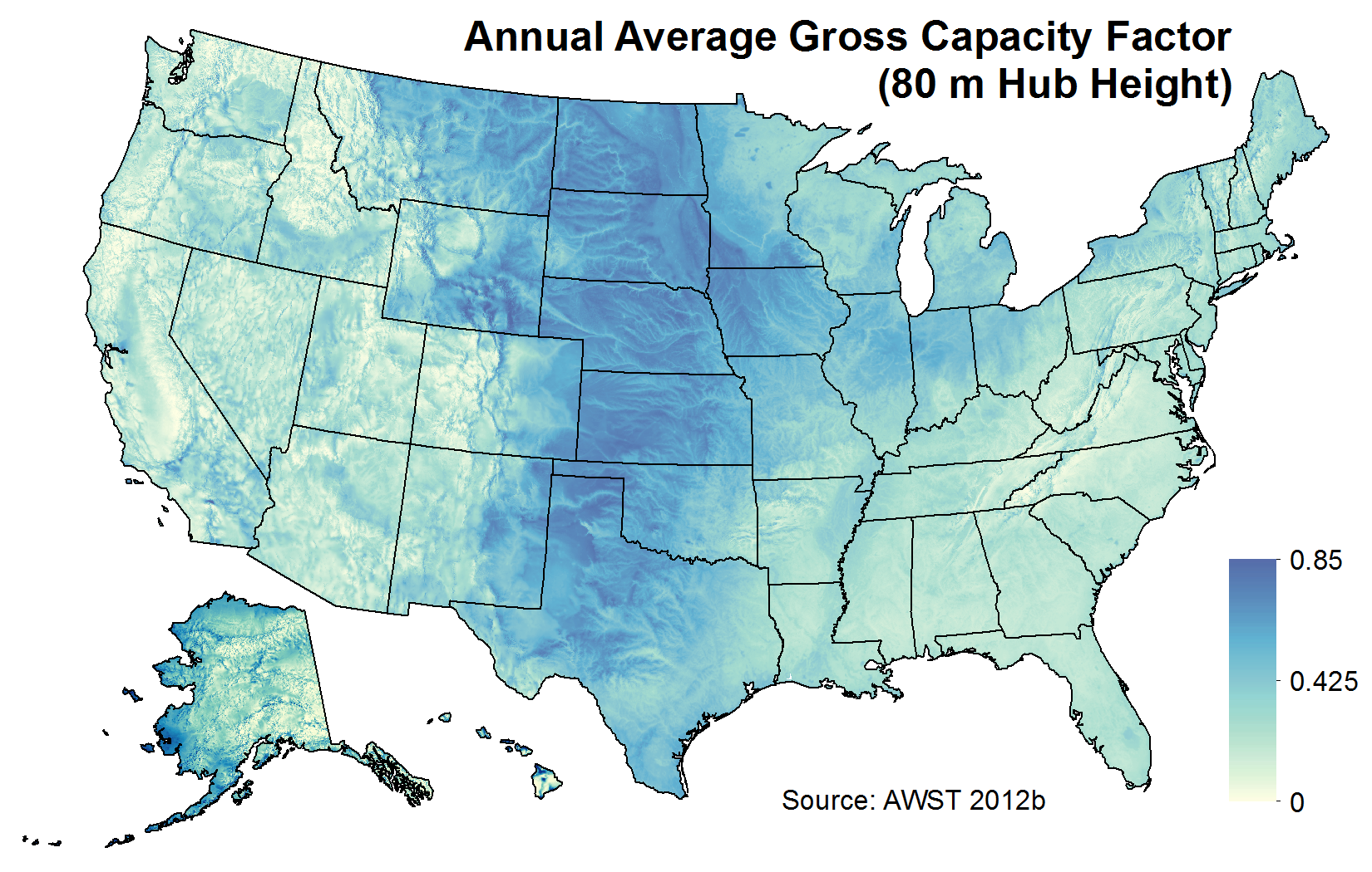

Figure 13. Annual average gross capacity factor for a modeled International Electrotechnical Commission Class II turbine at an 80-m hub height and 200-m horizontal resolution (AWST 2012a)

In dGen, agents can install turbines at hub heights of 20, 30, 40, 50, and 80 m above ground to facilitate access to various levels of wind resource. The wind speed profiles from AWS TruePower are currently available at heights of 30, 50, and 80 m. To model wind generation at 20 and 40 m, NREL has applied a vertical wind shear adjustment to the 30-m TMY profiles. The wind shear adjustment is derived from Elliott et al. (1986):

$$V_{d}=V*{\left(\frac{H_{d}}{H}\right)}^{∝} (5)$$

where *V* is the known wind speed at a given height *H*, and *Vd* is the derived wind speed at a given height *Hd*. The value for α (alpha) can be derived empirically by comparing wind speeds at two different heights above ground. Using the 30- and 50-m height TMY profiles, NREL has derived alpha values on an hourly basis and applied them to derive estimates of wind speed at 20- and 40-m hub heights for each location.

To convert the wind speed profiles into wind generation profiles, we applied each of the eight normalized turbine power curves described below to the hourly wind speed data profiles, adjusting for site-specific performance factors such as elevation. The result is an estimate of normalized annual energy production for each turbine power curve at five hub heights (20, 30, 40, 50, and 80 m) for every 200-m by 200-m grid cell across the United States.

Normalized annual energy production is derated in the model based on a default value of 0.85, which assumes 15% energy loss as a result of various factors (e.g., turbine downtime for maintenance and repair). This value is consistent with the *Wind Vision* study (DOE 2015); however, model users have the ability to alter this assumption for each turbine size class and model year.

B2. Turbine Performance

After a detailed review of power curves across the whole spectrum of sizes from 2 kW to 1.5 MW, we selected four power curves to represent the current, best available technology in its size range. The size ranges included residential (2.5 to 20 kW), small (50 to 100 kW), midsize (250 to 750 kW), and large (1,000 and 1,500 kW). These curves were normalized by the rated power of the turbine. In each case, the inverse of the power density was calculated. Then, the annual energy of the normalized power curve was calculated for a 5 meter per second average wind speed with a Rayleigh distribution. The output is in kilowatt-hours per kilowatt per year (kWh/kWp/yr). Peak power (kWp) was used because there is no standard rated wind speed for turbines larger than 200 m2 of swept area.

NREL constructed a generic power curve that was comparable to the normalized power curves. These generic power curves used the same swept area per kilowatt rating as the normalized curves and assumed a fixed efficiency that produced the same annual energy. Although this approach gives a slightly different power curve shape, it creates an easy format to compare across size ranges and avoids the confusion and complexity of trying to represent pitch-regulated versus stall-regulated and variable-speed versus fixed-speed power curves. The results for the current performance are summarized in Table 6.

Table 6. Baseline 2015 Distributed Wind Turbine Performance

|  |  |  |  |
| --- | --- | --- | --- |
| Turbine Size | Rotor Efficiency | Turbine Efficiency | Power Curve (Figure 14) |
| Residential | 3.07 m2/kWp | 29.0% | 1 |
| Small | 4.9 m2/kWp | 37.5% | 2 |
| Midsize | 3.1 m2/kWp | 42.0% | 3 |
| Large | 4.9 m2/kWp | 38.5% | 4 |

Starting with the premise that the current large turbine is fairly mature technology and not going to make dramatic increases in performance, we adjusted the large generic power curve in the far future case to 5.2 m2/kWp and 44% efficiency, which represents less than a 16% improvement in annual energy at a 5-meter per second average wind speed.

The midsized turbine selected is on the large end of the scale and incorporates active pitch and variable speed. Even though it has a small swept area for its rating, it is very efficient. As a result, we considered it to be a mature technology for efficiency. Therefore, although the swept area to rating is increased from its current low point in two steps to the same high value as the far future large turbine, the efficiency is only increased 1% at each step. The far future normalized power curve for the midsized turbine is the same as the curve for the far future large turbine. There does not appear to be any technical reason for a difference in performance between the large and midsize turbines. The question is if there will be a sufficient investment in this size range to achieve these results.

Originally, the small turbine category included what is now referred to as residential; however, there was such a large difference between the small end of the category and the large end (100 kW) that we could not represent it accurately as one segment. There are turbines at the 50- and 100-kW scale that perform at a similar level as the larger turbines. In other words, these turbines are fairly mature in the area of performance. This is not the case for turbines of 20 kW or less. Even though they start with different performance, 3.07 m2/kWp and 29% efficiency for residential and 4.9 m2/kWp and 37.5% efficiency for small, in two steps they both end up at 5.2 m2/kWp and 40% efficiency (Table 7).

Table 7. Future performance characteristics for the different turbines used in dGen

|  |  |  |  |  |
| --- | --- | --- | --- | --- |
| **Turbine Size** | **Rotor Efficiency m2/kWp** | **Turbine Specific Power (W/m2)** | **Capacity Factor** | **Power Curve (Figure 14)** |
| Residential | 3.07 | 326 | 0.290 | 1 |
| Small (>20 and <=100) | 4.90 | 204 | 0.375 | 2 |
| Midsize (>100 and <1,000) | 3.10 | 323 | 0.420 | 3 |
| Large (>1,000) | 4.90 | 204 | 0.385 | 4 |
| Near Future Residential | 4.00 | 250 | 0.325 | 5 |
| Far Future Residential | 5.20 | 192 | 0.400 | 6 |
| Near Future Small | 4.90 | 204 | 0.385 | 4 |
| Far Future Small | 5.20 | 192 | 0.400 | 6 |
| Near Future Mid | 4.20 | 238 | 0.430 | 7 |
| Far Future Mid | 5.20 | 192 | 0.440 | 8 |
| Far Future Large | 5.20 | 192 | 0.440 | 8 |

Figure 14. Normalized wind turbine power curves used to calculate power production based on size and technology evolution

B3. Turbine Height and Size Restrictions

As described in Section B1, dGen simulates annual and hourly wind energy production at a range of turbine hub heights for every 200-m by 200-m grid cell across the continental United States. These resource estimates are then linked to agent locations using a simple graphical information system (GIS) spatial overlay.

Although wind resource is modeled at several heights for every agent location, each agent may have only a limited set of allowable turbine hub heights and system sizes based on its local siting considerations. Specifically, the allowable turbine heights and sizes for each agent are constrained in the model based on three local factors: parcel size, degree of existing development, and nearby tree canopy density and height. These local factors have been set for each agent location in the model through a GIS analysis of fine-resolution, national geospatial datasets; however, the specific assumptions relating these factors to ranges of allowable turbine heights are flexible inputs that can be adjusted by users of the wind information in dGen. Together, these three factors are used to provide a nationwide approximation of the legal (i.e., zoning, safety) and operational constraints affecting distributed wind development. Figure 15 provides an overview of the processes used to analyze each factor and how they are combined to determine the range of allowable turbine heights at each agent location.

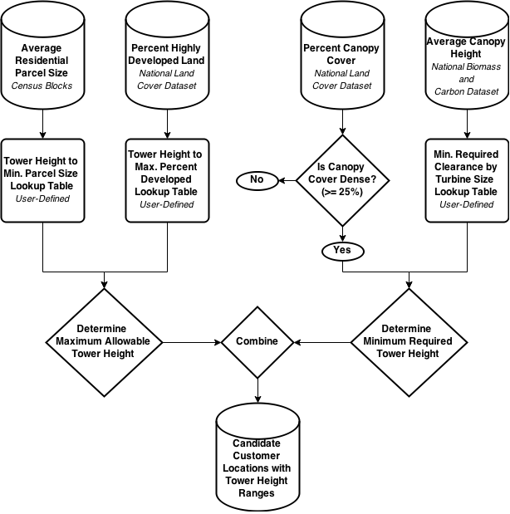

Figure 15. Graphical workflow illustrating the analysis used to develop and combine each of the factors that affects the range of developed turbine hub heights at each customer location.

The average residential parcel size is the first factor used in determining turbine height restrictions. This factor was selected as an important constraint because, during discussions between NREL and representatives from the Distributed Wind Energy Association, parcel size was highlighted as an important first-order indicator for the feasibility of installing different-height turbines. Nationwide parcel datasets are not freely available; therefore, as an alternative, dGen uses estimates of acres per housing unitderived from the Census 2010 at the block level. Blocks are the smallest available geographic region for Census data (U.S. Bureau of the Census 1994). Due to their fine spatial resolution, blocks allow for capturing sufficient spatial heterogeneity to differentiate patterns in parcel size between agent locations. In dGen, the maximum allowable turbine height allowed at each agent location is constrained by the average residential parcel size for the intersecting block, and a user-defined table that defines minimum required parcel size for each of the turbine hub heights evaluated in the model (Table 8). The current default values shown in Table 8 are based on preliminary feedback from Distributed Wind Energy Association representatives.

Table 8. User input table defining minimum parcel size required for each turbine hub height, populated with current default values

|  |  |
| --- | --- |
| **Turbine Hub Height (m)** | **Minimum Parcel Size (acres)** |
| 20 m | 0.50 |
| 30 m | 1.00 |
| 40 m | 2.00 |
| 50 m | 3.00 |
| 80 m | 4.00 |

Because the Census block data only account for residential development, a secondary dataset was used to assign an overall degree of all developed land to each customer location. These data were derived from the fine-resolution (30-m by 30-m) National Land Cover Dataset 2011 (NLCD) (Jin et al. 2013), which includes a “High Intensity” land class that constitutes “highly developed areas where people reside or work in high numbers” including “apartment complexes, row houses and commercial/industrial” (MRLC 2001). Given the intensity of development associated with this land class, dGen assumes that portions of agent locations that it occupies cannot be developed for wind. The percent of each 200-m by 200-m agent location covered by this land class was derived from the finer resolution NLCD grid. To translate the percent of highly developed land at each location to a turbine height constraint, dGen allows the user to define the maximum percentage of heavily developed land at an agent location for each of the turbine hub heights evaluated in the model (Table 9). The current default values shown in Table 9 were derived by NREL analysts based on the assumption that a turbine of hub height HH requires a minimum area of undeveloped land equal to (2HH)2 and that the non-highly-developed land within each agent location is optimally configured in a contiguous square area.

Table 9. User input table defining the maximum allowable percent of heavily developed land at each agent location for each turbine hub height, populated with current default values

|  |  |
| --- | --- |
| **Turbine Hub Height (m)** | **Maximum % Heavily Developed Land** |
| 20 m | 96% |
| 30 m | 91% |
| 40 m | 84% |
| 50 m | 75% |
| 80 m | 26% |

The third factor that contributes to the range of allowable turbine heights in dGen is the density and height of the tree canopy around each agent location. The density of the canopy cover was determined using a fine-resolution (30-m by 30-m) grid of percent canopy that is included as a component of the NLCD (2011) (Jin et al. 2013). Agent locations with an average canopy cover less than 25% are treated in the model as “low density canopy” and are not assigned any additional turbine height requirements. This threshold was selected by NREL analysts and can be adjusted in dGen if necessary. Locations with canopy coverage above this threshold are further evaluated in the model by determining the average canopy height, which was derived from the fine-resolution (30-m by 30-m) National Biomass and Carbon Dataset (Kellndorfer et al. 2012). At locations with high canopy density, the canopy height is combined with a user-defined minimum required clearance above tree cover for each turbine size (e.g., 20 m clearance for a 10 kW turbine) (Table 10) to constrain the range of allowable turbines. The current default values for minimum required canopy clearances shown in Table 10 were derived assuming a static clearance of 15 m for all turbines, plus a scalar factor of 1.1 times the approximate turbine radius.

Table 10. User input table defining the canopy clearance required for each turbine size (i.e., rated capacity), populated with current default values

|  |  |  |
| --- | --- | --- |
| **Turbine Size (kW)** | **Approx. Rotor Radius (m)** | **Required Clearance (m)** |
| 2.5 kW | 2.2 | 17.20 |
| 5 kW | 3.1 | 18.10 |
| 10 kW | 4.4 | 19.40 |
| 20 kW | 6.2 | 21.20 |
| 50 kW | 9.8 | 24.80 |
| 100 kW | 13.8 | 28.80 |
| 250 kW | 21.9 | 36.90 |
| 500 kW | 30.9 | 45.90 |
| 750 kW | 37.8 | 52.80 |
| 1000 kW | 43.7 | 58.70 |
| 1500 kW | 53.5 | 68.50 |

B4. Distributed Wind Costs

This section describes the process used to develop the turbine capital cost used in dGen. Our goal is to assess the current costs of distributed wind turbines and develop reasonable cost extrapolations for those areas in which we do not have sufficient data. Methods used to develop future cost expectations will be released in subsequent publications.

Procedure Summary for Current Installed Costs

NREL examined several data sets to determine the median installed cost for each size of turbine (rated power) as well as the most common hub heights for each size. We decided to use median costs, rather than mean costs, to minimize bias caused by data outliers. For each size, this median cost was assumed to apply to the most common hub height for that size. The procedure used to develop the costs is summarized in Figure 16.

Our cost data sets do not provide sufficient resolution to determine the marginal cost of taller towers. As a result, we consulted with various tower wholesalers, distributed original equipment manufacturers, and project developers for this information. We obtained sufficient data for the small and utility size ranges but collected little data for turbines of 250 to 750 kW. The available data were then used to develop a marginal tower height cost adjustment for each turbine size provided in the model.

To keep the model run times reasonable, dGen offers only a few tower heights (in 10-m increments). For each turbine size, the tower height range determined from the data was adjusted to fit these increments. The marginal tower height costs were used to develop an estimated installed cost for a turbine using the shortest tower height allowed for each turbine size. We then plotted the installed cost versus the log of the rated power and determined the best fit line and then used that result to determine the adjusted costs for each turbine size at the minimum tower height used in the model.

For each turbine size, the data used in the model consist of turbine final adjusted installed cost (i.e., the cost for the minimum tower height), the heights available in the model for that size turbine, and the marginal height cost to allow for cost estimates of installations using towers that are taller than the minimum height.

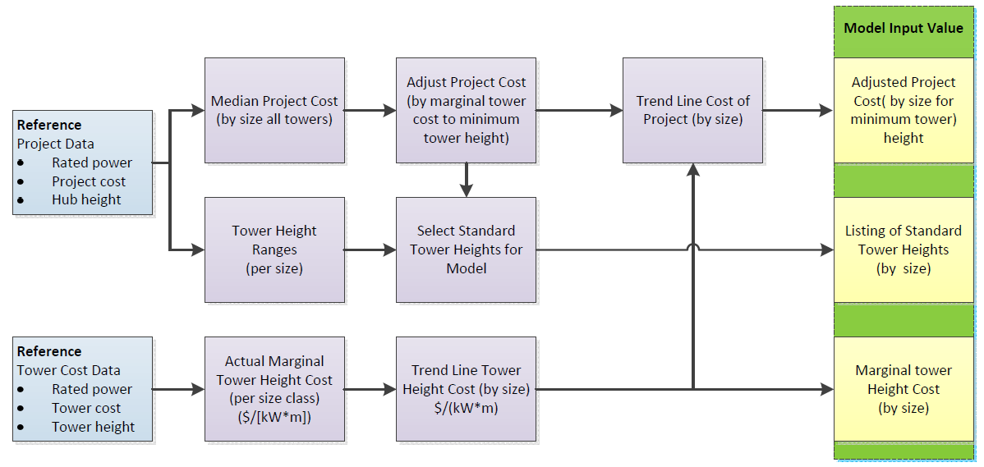

Figure 16. Procedure for determining installed cost values used for wind in dGen

Turbine Costs

NREL based the initial installed costs on the cost data from a non-public database of project-level characteristics funded under the US Department of Treasury 1603 program. We used median project costs in developing data for dGen rather than the average costs because (in several cases) the average costs are somewhat skewed as a result of outliers in the respective samples. To verify the costs from the 1603 database, we also cross-validated costs from other sources.

Height as a Function of Rated Power

To determine the typical range of hub heights for each turbine size class, we analyzed turbine hub height data from the 1603 database and other sources, plotting the data on a histogram. Table 11 shows the distribution of tower heights for projects using turbines of various rated powers. The table shows some anomalies. For example, 10-kW turbines tend to be on taller towers than 20-kW turbines, and 100-kW turbines tend to be on shorter towers than 50-kW turbines. This discrepancy is not surprising considering the limited number of manufacturers in each size and the limited data set. In the midsized turbine range, manufacturers informed us that they were selling additional sizes, so we added those as well.

Table 11. Histogram of Turbine Height and Rated Power

|  |  |  |  |  |  |  |  |  |  |  |  |  |  |  |  |  |
| --- | --- | --- | --- | --- | --- | --- | --- | --- | --- | --- | --- | --- | --- | --- | --- | --- |
| **Number of Projects using Turbines with the Listed Hub Height** | | | | | | | | | | | | | | | | |
| **Turbine Class (kW)** | **9 m– 12 m** | **14 m– 17 m** | **18 m–20 m** | **21 m–25 m** | **30 m** | **34 m** | **37 m** | **43 m** | **50 m** | **55 m** | **60 m** | **65 m** | **70 m** | **75 m** | **80 m** | **87 m** |
| **2.5** | 3 | 15 | 3 |  |  |  | 2 |  |  |  |  |  |  |  |  |  |
| **5** | 1 |  |  | 1 | 1 |  | 1 |  |  |  |  |  |  |  |  |  |
| **10** |  | 3 | 1 | 3 | 7 | 2 | 26 | 5 |  |  |  |  |  |  |  |  |
| **20** |  |  | 4 | 14 | 11 | 12 |  |  |  |  |  |  |  |  |  |  |
| **50** |  |  |  |  | 6 | 1 | 5 | 31 |  |  |  |  |  |  |  |  |
| **100** |  |  |  |  | 3 |  | 23 |  |  |  |  |  |  |  |  |  |
| **200** |  |  |  |  |  |  |  |  | 1 |  |  |  |  |  |  |  |
| **500** |  |  |  |  |  |  |  |  | 2 | 1 |  | 1 |  |  |  |  |
| **750–850** |  |  |  |  |  |  |  |  | 1 | 1 |  | 1 |  |  |  |  |
| **900–1,000** |  |  |  |  |  |  |  |  |  | 1 |  |  |  | 2 |  |  |
| **1,500–1,700** |  |  |  |  |  |  |  |  |  |  | 2 |  | 1 |  | 6 | 1 |

Marginal Tower Height Costs

In addition to typical hub heights, dGen needs estimates for the marginal cost of taller towers. The project cost data from the various data sets were too scattered or sparse to allow for an accurate determination of how the project cost changes with changes in tower height. As a result, we contacted various turbine and tower manufacturers to get tower prices for different turbine sizes. The data are most robust for small- (up to 10 kW) and utility-scale turbines, with limited data available for midsize turbines.

Increasing the tower height also increases other installation costs, such as foundation and erection costs; however, the bulk of the cost difference is in the tower cost and foundation, and installation cost data were not readily available. To get hard numbers, we limited our data collection to tower cost data.

Because the data for the full range of sizes did not fit a log function curve, NREL used a piecewise best fit and adjusted the end points where there were good data. The 5- and 10-kW towers were based on lattice tower costs, because they are the most common in the installed base. The 2.5- and 50-kW-plus were based on monopole towers, because they are the most common and increasing in popularity. The results of this adjustment are presented in Table 12.

Table 12. Marginal Tower Cost

|  |  |
| --- | --- |
| **Turbine Size (kW)** | **Marginal Tower Cost (Best Fit Line) ($/[kW*m])** |
| 2.5 | $211 |
| 5 | $164 |
| 10 | $118 |
| 20 | $71 |
| 50 | $15.7 |
| 100 | $11.3 |
| 250 | $10.8 |
| 500 | $9.9 |
| 750 | $9.0 |
| 1,000 | $8.1 |
| 1,500 | $6.4 |

Final Cost Data for Model Input

NREL used the tower height marginal cost to adjust the project cost data to the minimum tower height for each size. Table 13 compares the tower height range in data and for use in the model. We then plotted project capital costs versus the log of the turbine size class. The data from 5 to 100 kW produce a reasonable log curve that smoothes out the discrepancy in the 20- and 50-kW cost. The cost per kilowatt of 50-kW turbines is higher than the cost of 20-kW turbines. The common 20-kW turbine models have rotors that are undersized for the given rated power, thus decreasing their costs (on a per- kilowatt basis). In contrast, the common 50-kW turbine model has an oversized rotor that increases its cost per kilowatt.

Table 13. Comparison of Actual Tower Height Ranges to the Ranges used in the Model

|  |  |  |  |  |  |  |  |  |
| --- | --- | --- | --- | --- | --- | --- | --- | --- |
|  | **Typical Height Range from Data** | | | **Wind turbine height range used in dGen** | | | | |
| **Turbine Size Class (kW)** | **Min Height (m)** | **Typical Height (m)** | **Max Height (m)** | **Turbine Height Option 1 (H1)** | **Turbine Height Option 2 (H2)** | **Turbine Height Option 3 (H3)** | **Turbine Height Option 4 (H4)** | **Turbine Height Option 5 (H5)** |
| **2.5** | 9 | 14 | 18 | 20 | 30 |  |  |  |
| **5** | 24 | 24 | 37 |  | 30 | 40 |  |  |
| **10** | 30 | 37 | 43 |  | 30 | 40 | 50 |  |
| **20** | 24 | 30 | 37 |  | 30 | 40 | 50 |  |
| **50** | 37 | 43 | 43 |  | 30 | 40 | 50 |  |
| **100** | 30 | 37 | 37 |  |  | 40 | 50 |  |
| **250** |  |  |  |  |  |  | 50 |  |
| **500** |  |  |  |  |  |  | 50 | 80 |
| **750** |  |  |  |  |  |  | 50 | 80 |
| **1,000** |  |  |  |  |  |  |  | 80 |
| **1,500** | 70 | 80 | 80 |  |  |  |  | 80 |

On the small end of the scale, the costs by size were changing too rapidly to include the 2.5-kW size class in the trend line. In some cases in which we had good data, we used the actual data versus a trend line. Because the 1603 data for the 1,500-kW size class were already below the data from other sources, and the trend line would reduce it further, we used the actual data. The final default values for current installed cost are presented in Table 14.

Table 14. Final Adjusted Turbine Costs

|  |  |  |  |  |
| --- | --- | --- | --- | --- |
| **Turbine Size Class** | **Turbine Rated Power (kW)** | **Adjusted Cost ($/kW)** | **Installed Cost** | **Minimum Hub Height (m)** |
| 2.4–2.5 kW | 2.5 | $10,045 | $25,113 | 20 |
| 5 kW | 5 | $7,785 | $38,925 | 30 |
| 10 kW | 10 | $6,914 | $69,145 | 30 |
| 20 kW | 20 | $6,459 | $129,186 | 30 |
| 50 kW | 50 | $5,858 | $292,879 | 30 |
| 100 kW | 100 | $5,402 | $540,238 | 40 |
| 250 kW | 250 | $3,525 | $881,232 | 50 |
| 500 kW | 500 | $2,961 | $1,480,283 | 50 |
| 750 kW | 750 | $2,630 | $1,972,827 | 50 |
| 1,000 kW | 1,000 | $2,396 | $2,396,206 | 80 |
| 1,500 kW | 1,500 | $2,185 | $3,277,628 | 80 |

Operation and Maintenance Costs

Data on the cost of both scheduled (preventative) maintenance and unscheduled (repair) maintenance were gathered from a wide variety of sources, including manufacturers, leasing companies, installers, and consultants. The level of confidence that the data reflect long-term costs varies. Manufacturers have an incentive to be optimistic, and some likely were. Leasing companies and consultants that are estimating future project operating cost are motivated to estimate high. Installers who provide maintenance support are reporting their real costs, so these are likely the most reliable data, but in some cases they reflect experience of turbines that are in the first part of their life. These data may not be representative of the average cost in the later part of a turbine’s design life.

Scheduled maintenance cost data are easier to obtain and more reliable because they are not likely to shift significantly over the life of the system. We obtained more scheduled maintenance cost data than unscheduled maintenance cost data, and we have used the data to develop a linear trend line for both types of costs. For each size we added the value of the scheduled and the unscheduled maintenance costs from the linear trend line (Table 15, Figure 17).

Two serious weaknesses in the data may affect the results. First, there are no data for unscheduled maintenance from any source for turbines under 10 kW. Second, the only unscheduled maintenance data for turbines over 660 kW are a consultant’s projection for 1.5-MW turbines. These limitations make it impossible to develop confidence in the accuracy of a linear trend line. There are not enough data points, and the confidence level in each data point varies.

In addition, two transitions could have a significant impact on the results. All turbines above 100 kW have gearboxes, and most are active-pitch systems. There is a transition region in the 50- to 100-kW class size in which there are both geared and direct-drive systems, and then all turbines under 50 kW (at least in our samples) are direct drive and have electric brakes and passive yaw. These features reduce maintenance costs. Turbines rated at 2.5 kW are designed for no scheduled maintenance. As a result, these transitions overcome some of the scale effects on maintenance costs; however, we do not have the data required to tease out the impacts of these technology-scale transitions. In addition, one turbine manufacturer supplied data on unscheduled maintenance that clearly reflected some design-based reliability issues. We did not use those data and instead used trend line data for that size.

Table 15. Operation and Maintenance Cost Assumptions

|  |  |  |  |  |
| --- | --- | --- | --- | --- |
| **Rating (kW)** | **Total Maintenance Trend Line ($/kW)** | **Scheduled Maintenance ($/kW)** | **Unscheduled Maintenance ($/kW)** | **Total Maintenance ($/yr)** |
| 2.5 | $38.94 | $27.64 | $11.30 | $97 |
| 5 | $38.92 | $27.62 | $11.30 | $195 |
| 10 | $38.88 | $27.58 | $11.30 | $389 |
| 20 | $38.80 | $27.50 | $11.30 | $776 |
| 50 | $38.56 | $27.27 | $11.29 | $1,928 |
| 100 | $38.15 | $26.87 | $11.28 | $3,815 |
| 250 | $36.94 | $25.69 | $11.25 | $9,234 |
| 500 | $34.91 | $23.71 | $11.20 | $17,456 |
| 750 | $32.89 | $21.74 | $11.15 | $24,665 |
| 1,000 | $30.86 | $19.76 | $11.10 | $30,862 |
| 1,500 | $26.81 | $15.81 | $11.00 | $40,218 |

Figure 17. Wind turbine operation and maintenance cost assumptions by size used in dGen

Appendix C. Linkage with ReEDS Capacity Expansion Model[8]

The economics of DERs, particularly PV, have improved rapidly, resulting in acceleration in the amount of capacity deployed. As such, there are important implications of increased levels of DER generation for operation of the bulk power system; notably, large-scale adoption may result in revenue loss for utility companies and additional investments in transmission and distribution infrastructure to accommodate these new, variable sources of generation (Funkhouser et al. 2015; Satchwell et al. 2015a; Satchwell et al. 2015b). In addition, increased levels of distributed generation will reduce demand for competing sources of generation, such as natural gas or coal-fired generation stations, or other renewable technologies such as utility-scale solar or land-based wind. These issues, coupled with the continuing decline of PV prices and associated increase in installations, prompted us to improve the modeling capabilities to better study the interaction of deployment of rooftop PV on the U.S. electricity system and, in turn, the impacts of the U.S. electricity system on DER deployment.

In order to examine the interaction between DER deployment and the bulk power electricity system, we completed a module that links dGen to NREL’s ReEDS model. At the time of writing, only the solar portion of dGen (the dSolar module) had been fully linked with ReEDS. ReEDS is a utility-side model that makes decisions as a system-wide planner for power plants nationwide based on a least-cost optimization. Because DERs are based on the decisions of individuals and businesses, the ReEDS central planning framework is inappropriate for DER adoption. On the other hand, dGen was specifically designed to model consumer adoption.

The ReEDS capacity expansion model (Short et al. 2011; Sullivan et al. 2015) is an optimization model that assesses the deployment and operation (including transmission) of the electricity sector of the contiguous United States from 2010 through 2050. It emphasizes the integration of renewable energy technologies into the grid. ReEDS represents renewable energy resources through the use of 356 individual resource regions (for CSP and wind resources) and 134 balancing areas (for utility PV, all other generation types, demand, and transmission) across the continental United States (Figure 18). ReEDS includes explicit representation of key issues related to renewable energy, such as variability and uncertainty in wind and solar output, transmission costs and constraints, and ancillary services requirements. ReEDS includes a full suite of conventional generating technologies, a reduced-form dispatch that reflects seasonal and diurnal load shapes, an aggregated transmission network, and dynamic natural gas supply curves. The major conventional thermal generating technologies in ReEDS include simple and combined cycle natural gas, several varieties of coal, oil/gas steam, and nuclear. In addition to conventional generators, ReEDS models geothermal, hydropower, biopower, wind, and solar energy resources. For solar energy technologies, ReEDS models central utility PV, distributed utility PV, and CSP with and without thermal energy storage. ReEDS does not explicitly model rooftop PV deployment; instead rooftop PV deployment is specified as an exogenous input in ReEDS. Electricity storage technologies in ReEDS include pumped-hydropower storage, compressed-air energy storage (CAES), and sodium sulfur batteries.

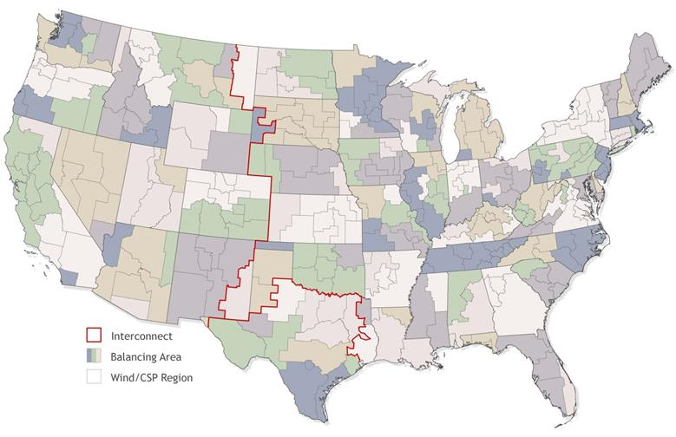

Figure 18. ReEDS map showing the ReEDS regional structure; ReEDS includes 134 model balancing areas (shaded areas) and 356 wind and CSP resource regions (light gray lines)

ReEDS and dGen are linked as shown in Figure 19.[9] In the linked mode, dGen runs before ReEDS in a given year and passes the quantities of installed capacity, capacity factor, and assumed retail electricity prices of adopters to ReEDS. ReEDS uses the installed capacity and capacity factors to determine the amount of generation supplied for each DER technology. While both models can generate internal estimates of retail rate changes, the assumptions are reconciled between both models to harmonize the ReEDS retail electricity price calculations. Once ReEDS receives the dGen inputs, it solves the capacity expansion and dispatch problem for the year and returns a number of parameters to dGen to inform subsequent simulation in dGen.

**dGen - 2014**

Rooftop PV Adoption

**ReEDS - 2014**

Bulk Power System

**dGen - 2016**

Rooftop PV Adoption

**ReEDS - 2016**

Bulk Power System

…

**dGen - 2050**

Rooftop PV Adoption

**ReEDS - 2050**

Bulk Power System

◆ Rooftop PV capacity by region

❖ Capacity factor by time slice

⬥ Retail electricity prices of adopters

 Rooftop PV marginal curtailment rate











Figure 19. Schematic of the ReEDS-dGen linkage; dGen passes rooftop PV capacity, capacity factors, and retail electricity prices to ReEDS before each ReEDS solve, and ReEDS returns the rooftop PV marginal curtailment rate for the next dGen year

A fundamental question in modeling PV and other variable renewable resource energy (VRRE) technologies is accurately representing the impact of increasing levels of VRRE sources on bulk power operation. Generally, VRRE sources have been shown to have decreasing value at higher levels of penetration, primarily through erosion in capacity value (Sigrin et al. 2014; Mills and Wiser 2012). An additional nuance for DERs is that it is likely that incentives, rate structures, and other market factors specific to the valuation of DER technologies will experience changes to accommodate utility revenue loss. We use the marginal curtailment ReEDS calculates as a proxy mechanism for incorporating both types of feedback where, as the penetration of all VRRE (utility scale or distributed-scale) increases, the increasing curtailment levels reduce the attractiveness of subsequent deployment.

The marginal curtailment rate from ReEDS is calculated for each VRRE technology as the additional curtailment induced by adding 100 MW of that technology in a region divided by the total generation from 100 MW of the VRRE technology in that same region.[10] Thus ReEDS includes a unique marginal curtailment rate for each of its 134 regions. There are currently three methods in dGen for applying the marginal curtailment rate of rooftop PV from ReEDS (the method is set by the user): 1) ignore the curtailment rate (no curtailment), 2) apply the curtailment rate only to electricity that is exported to the grid (net curtailment), or 3) apply the curtailment rate to total generated electricity (full curtailment).[11] The linked model is referred to as the ReEDS-dGen model.

1. In the agent-generation stage, each agent considers a set of possible configurations, many of which are untenable. In the economics module, the agent will “choose” a single configuration that offsets a given fraction of their energy consumption while maximizing their utility (if any such configurations exist).
2. For example, in Jefferson County, Colorado, there are 8,219 distinct residential customer locations in the land-use mask but only 220 unique combinations of attributes (as currently modeled) across those locations.
3. Because of data limitations on industrial energy consumption, the Commercial Building Energy Consumption Survey is also used to categorize the energy consumption of industrial customers.
4. Although non-owner-occupied commercial and industrial buildings may adopt, they do so at a lower rate than owner-occupied structures.
5. <http://www.nrel.gov/gis/images/map_pv_us_annual10km_dec2008.jpg>
6. Based on currently available technology, 10 m2 is approximately enough area for a 1.3 kW system.
7. <https://www.californiasolarstatistics.ca.gov/data_downloads/>
8. This appendix is a summary of a forthcoming journal article: Cole, W., Lewis, H., Sigrin, B., Margolis, R. (2015) Interactions of Rooftop PV Deployment with the Evolution of the Bulk Power System. *Forthcoming*

  
9. ReEDS solves from 2010–2050, while dGen operates from 2014–2050 (both models function for only the even years). For years prior to 2014, ReEDS uses historical DER deployment in lieu of inputs from dGen.
10. The methodology used for these marginal curtailment rate calculations is described by Dragoon and Dvortsov (2006), with details on the ReEDS implementation described by Short et al. (2011).
11. Because of how dGen is structured, the curtailment rate is applied to the bill savings induced from the rooftop PV system. If the adopter has flat electricity rates, this is equivalent to applying the curtailment rate to the actual electricity production. In the case of other rate structures, this method approximates what would happen if actual electricity production were curtailed.